Contents

21. Sightly/HTL syntax with examples: 2

22. currentPage object, properties object, currentNode object in AEM: 6

23. Render basic page content in AEM: 6

24. Modularize the Page rendering (contentPage) component in AEM: 8

25. Inheritance: 9

26. Client Library (Theory): 12

27. Define a design in AEM (Client Library – Part 1) 14

28. Create client library in AEM (Client Library – Part 2) 16

29. Calling client library in AEM (Client Library – Part 3) 18

30. Assign a design to a website in AEM (Client Library – Part 4) 20

31. Creating simple Navigation Component 22

32. Responsive Navigation Component (using bootstrap classes) 25

33. Creating Complex Navigation component using Java Helper in AEM 27

34. Creating Complex Navigation component using JavaScript Helper in AEM 29

35. Introduction to Logs in AEM 31

36. Create Custom Log file using JavaScript in AEM 33

37. Add logging to the Java Helper in AEM 35

38. Touch Optimised dialog box and Classic dialog box in AEM 36

39. Create Title Component in AEM 38

40. Create a Touch-Optimised dialog box for the Title Component in AEM 40

# 21. Sightly/HTL syntax with examples:

**Slightly** *features* below things:

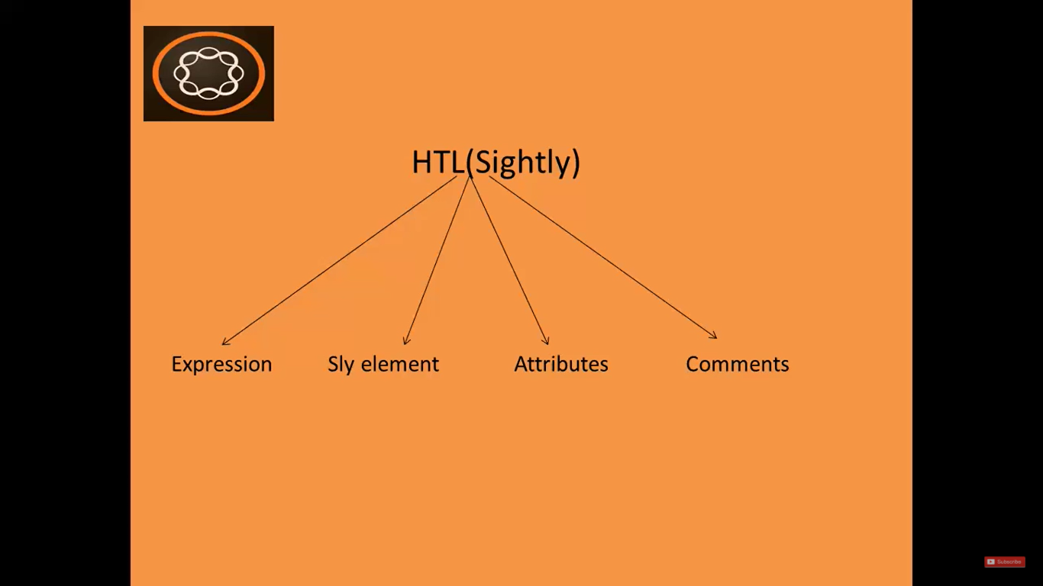

1. **HTL Comment:**

|  |  |
| --- | --- |
| **HTML Comment:** | <!-- *HTML* comment --> |
|  |  |
| **Sightly/HTL Comment:** | <!--/* *HTL* comment */--> |

It is ***recommended*** *to use* **Sightly comment** in AEM development. Because the *normal HTML gets rendered to final markup*.

If you **Right Click** on webpage and select option **View** **Page Source**, you will be *able to* ***see***the ***HTML comments***.

But if you have used **Sightly comments**, then those comments will **not be shown** in the **Page Source**.

Therefore, it is **recommended** to use **Sightly comment** over normal HTML comments.

1. **HTL Expressions:**

**HTL Expressions** are written using **${}**

These **expressions will be evaluated** *at run-time***,** and its **value will be injected** into the HTML.

**HTL** use **Expressions** to provide **dynamic elements** to **HTML output**.

Example,

**${currentPage.Title}** - It will render the **Title** from **currentPage** object.

We can use various **operators** in HTL expressions mentioned below:

|  |  |
| --- | --- |
| **Operator** | **Symbol** |
| NOT | ! |
| OR | || |
| EQUAL TO | == |
| GREATOR THAN | > |
| GREATOR THAN EQUAL TO | >= |
| LESS THAN | < |
| LESS THAN EQUAL TO | <= |

**Examples**,

${!currentPage.hasChild}

${varOne || varTwo}

${varOne == varTwo}

You can use these HTL expressions in **attributes**, **element content** and **comments**.

1. **Sly Element:**

**Sly element** is a <sly></sly> **tag** which *automatically* **removes itself** from the **final output**.

You can used **Sly element** for **all the elements** *which are* ***not*** *part of the markup*.

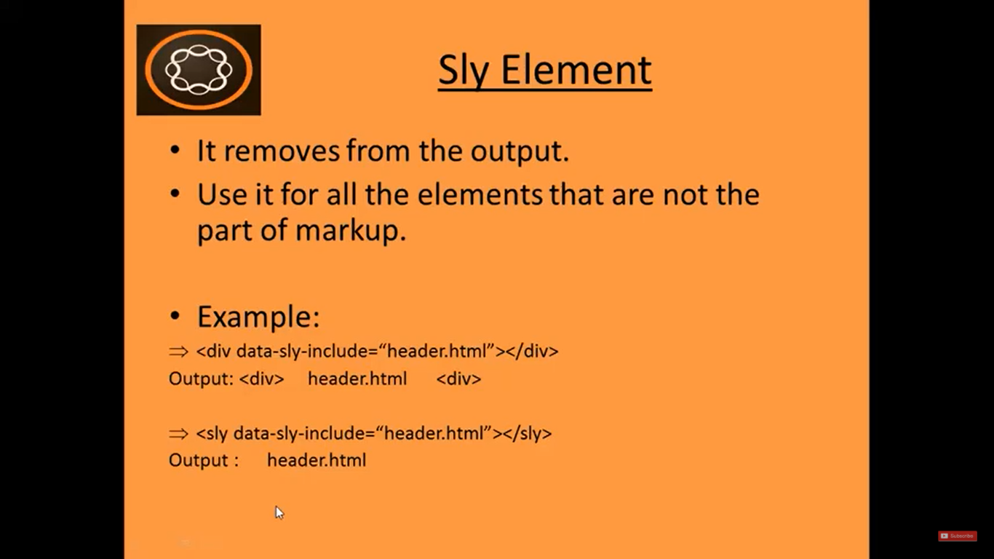

1. **Sly Attributes:**

|  |  |  |
| --- | --- | --- |
| **Slightly Attribute** | **Meaning** | **Example + Output** |
| data-sly-text | Replaces the content of the HTML element with the specified text. | <div data-sly-text=”${currentPage.Title}”>  Title Page  </div>  **Output:**  Before evaluation of expression: Title Page  After evaluation of expression: Value of expression. |
| data-sly-test | To hide or show an HTML element | <div data-sly-test= “${wcmmode.edit}”> This is edit mode </div>  **Output:**  ***In Edit/Author mode*** --> This is edit mode  ***In Preview mode*** --> <blank> |
| data-sly-list | Repeats the children elements | <ul data-sly-list="${ currentPage.listChildren }">     <li>  ${item.name} </li>  </ul>  **Output:** |
| data-sly-repeat | Repeats the element itself | <ul data-sly-repeat="${ currentPage.listChildren }">     <li>  ${item.name} </li>  </ul>  **Output:** |
| data-sly-include  [VIMP] | To include another HTML/JSP file. | <sly data-sly-include=“header.html”> <sly>  <sly data-sly-include=“body.html”> <sly>  <sly data-sly-include=“footer.html”> <sly>  **Output:**  This will render contents of **individual html files** on **current page**.  This way we can achieve **separation of concerns** & make **code clean**. |
| data-sly-resource [VIMP] | To include Component in the current page/component | <sly data-sly-resource=  ${‘par’ @ resourceType= ‘foundation/components/parsys’}>  </sly>  Output: This will include parsys component which already available in AEM. |
| data-sly-use | To invoke **helper file** (**JS** file). --->  So that **complex logic** will remain in the **external file** and can be **invoked here** using this attribute. | <div data-sly-use.comp=“logic.js”>  ${comp.myTitle}  </div>  We can use variable **myTitle** in **logic.js** as shown above. |
| data-sly-call | Use to **call**/invoke **client library** in your component. -->  Client library is where client-side libraries images/css/js are present. | data-sly-call = “${clientlib.all @ categories=‘cq.jquery’}” |
| data-sly-attribute | **Adds** **attributes** to the host element. | <div title="Lorem Ipsum" data-sly-attribute.title="${properties.jcr:title}"></div>  Sets **default** title attribute value to “Lorem ipsum”.  **Overwrites** title attribute value to ${properties.jcr:title} |
| data-sly-element | **Replaces** the **element** name of the **host element**. | <h1 data-sly-element="${newtag}">text</h1>  **Replaces** **h1** with the value of **newtag (**p tag, h3 tag, etc.) |
| data-sly-template  &  data-sly-call | **data-sly-template** defines a **template**.  **data-sly-call** - **calls** **a template** defined with data-sly-template. | <template data-sly-template.one>blah</template>  <div data-sly-call="${one}"></div>  **data-sly-template** defines a **template**. The host element and its content are not sent for output by HTL  **data-sly-call** - **calls** **a template** defined with data-sly-template. The content of the called template replaces the content of the host element of the call. |

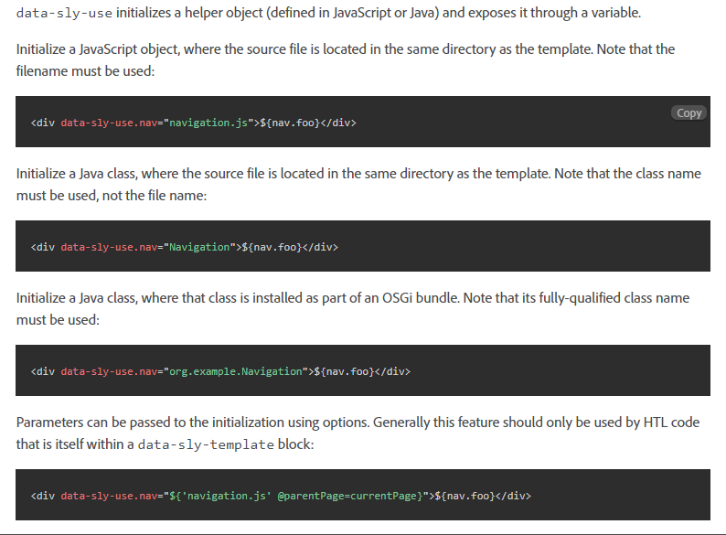

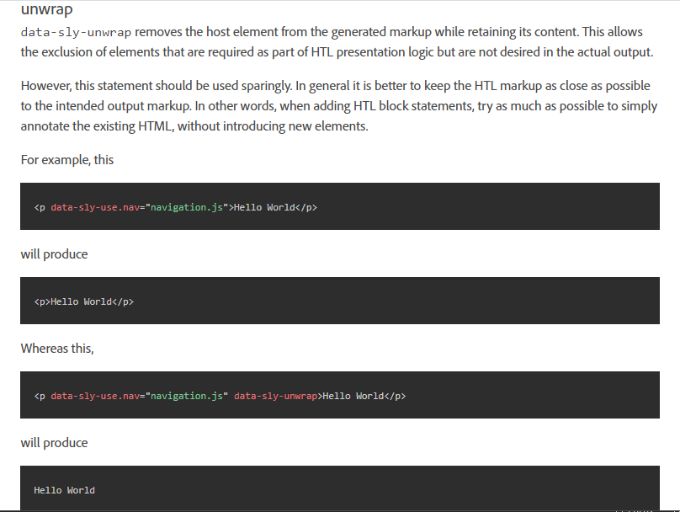

Refer <https://experienceleague.adobe.com/docs/experience-manager-htl/using/htl/block-statements.html?lang=en#htl> for more options or detailed explanation.

# 22. currentPage object, properties object, currentNode object in AEM:

1. This is the **introduction to the rendering the content** *fetched from the* ***repository (JCR)***.
2. This is a *similar to the concept of* **querying and displaying data from a database**.
3. So, ***using these objects*, we can access content** in AEM.

|  |  |  |
| --- | --- | --- |
| Object | Description | Syntax + Example |
| **currentPage** object | Instance of the **Page** *class* (**AEM API**).  It provides some ***methods*** to ***access content***. | ${currentPage.Title} |
| **properties** object | Instance of the **ValueMap** *class* (**Sling API**).  It contains all the ***properties*** of ***current resource***. | ${properties.jcr:Title} |
| **currentNode** object | Instance of the **Node** *class* (**JCR API**) | ${currentNode.Name} |

# 23. Render basic page content in AEM:

Go to <https://github.com/pankajchhatri/AEM> --> [Developer course](https://github.com/pankajchhatri/AEM/tree/master/Developer%20course) --> [Chapter 7 Introduction to Sightly](https://github.com/pankajchhatri/AEM/tree/master/Developer%20course/Chapter%207%20Introduction%20to%20Sightly) --> [Task - Render Basic Page Content](https://github.com/pankajchhatri/AEM/tree/master/Developer%20course/Chapter%207%20Introduction%20to%20Sightly/Task%20%20-%20Render%20Basic%20Page%20Content) --> [contentpage.html](https://github.com/pankajchhatri/AEM/blob/master/Developer%20course/Chapter%207%20Introduction%20to%20Sightly/Task%20%20-%20Render%20Basic%20Page%20Content/contentpage.html)

Copy entire content of this file and paste it to **CRX/DE** node --> **/apps/training/components/structure/contentpage/contentpage.html**

**FILE CONTENTS:**

<!doctype html>

<html>

<head>

<meta charset="utf-8"/>

</head>

<body>

<h1>Hello World!!</h1>

<h3>Sling PropertiesObject</h3>

<p>Page Title : ${properties.jcr:title}</p>

<h3>Page Details</h3>

<p>currentPage Title: ${currentPage.Title}</p>

<p>currentPage Name: ${currentPage.Name}</p>

<p>currentPage Path: ${currentPage.Path}</p>

<p>currentPage Depth: ${currentPage.Depth}</p>

<h3> Node Details </h3>

<p>currentNode Name: ${currentNode.Name}</p>

<p>currentNode Path: ${currentNode.Path}</p>

<p>currentNode Depth: ${currentNode.Depth}</p>

</body>

</html>

**OUTPUT:**

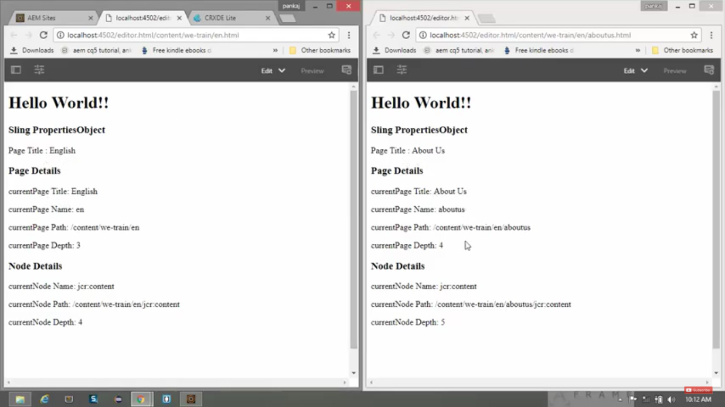

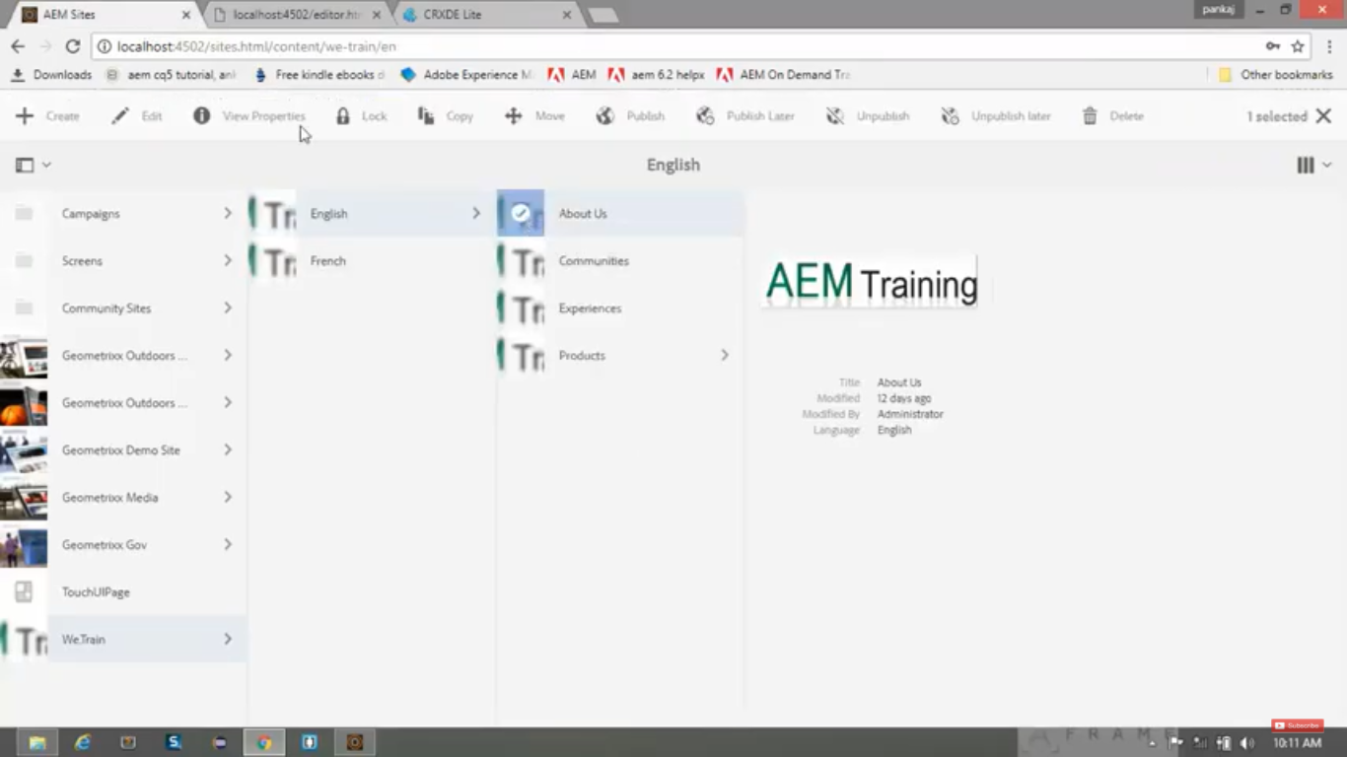

# 24. Modularize the Page rendering (contentPage) component in AEM:

* In this section, we will modularise our Page Rendering component (i.e. contentPage component)
* **Component Modularisation**:
  + **E*nables reuse of common structures***.
  + ***Avoids code redundancy****.*

1. **Right Click** on **CRX/DE** node **/app/training/component/structure**.

**Create** --> **Create File** (4 times) --> **contentpage.html, header.html**, **body.html**, **footer.html**.

1. Go to <https://github.com/pankajchhatri/AEM> --> [Developer course](https://github.com/pankajchhatri/AEM/tree/master/Developer%20course) --> [Chapter 7 Introduction to Sightly](https://github.com/pankajchhatri/AEM/tree/master/Developer%20course/Chapter%207%20Introduction%20to%20Sightly) --> [Task - Modularize Contentpage Component](https://github.com/pankajchhatri/AEM/tree/master/Developer%20course/Chapter%207%20Introduction%20to%20Sightly/Task%20-%20Modularize%20Contentpage%20Component)
2. **Copy** entire **content** of below files and **paste** it to respective **CRX/DE** files.

|  |  |
| --- | --- |
| 1) | **contentpage.html** |
| 2) | **body.html** |
| 3) | **header.html** |
| 4) | **footer.html** |

1. Click on **Save All** button present at top of the page.
2. Check in **body.html**, you can see there are **2** **data-sly-include** attributes as below:

|  |  |
| --- | --- |
| **Tag and attribute** | **Meaning** |
| <div data-sly-include=“header.html”> </div> | This will include header component in body component |
| <div data-sly-include=“footer.html”> </div> | This will include footer component in body component |

1. Check in **contentpage.html**, you can see there a “data-sly-include” attribute as below:

|  |  |
| --- | --- |
| **Tag and attribute** | **Meaning** |
| <div data-sly-include=“body.html”> </div> | It will include body component in contentpage component |

**OUTPUT:**

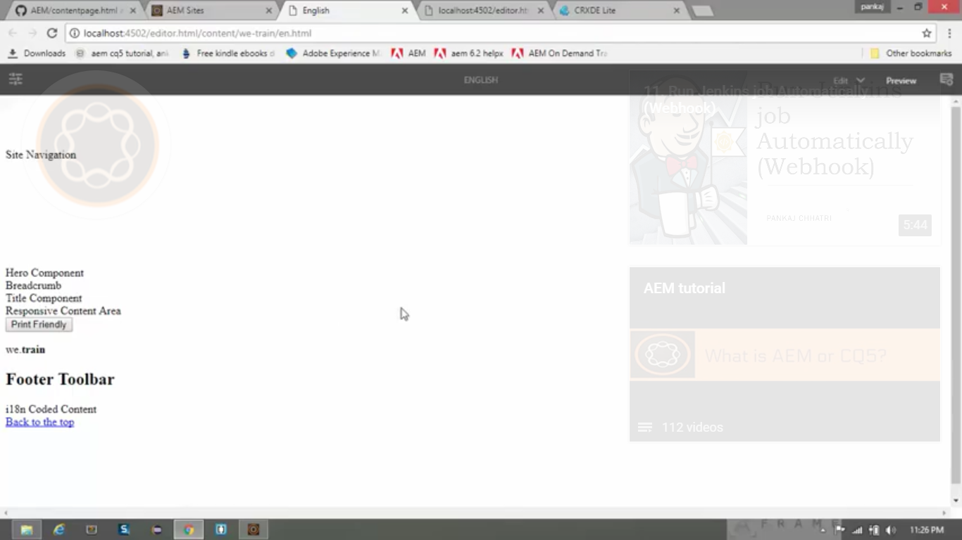

# 25. Inheritance:

1. One of the *powerful features* in AEM is to **inherit** ***from other existing components***.
2. **For example,** we have a **built-in** **component** named **Page** component in **AEM**.
3. We can **inherit all the functionalities** that is **already built-in** in this **AEM’s** built-in **Page** component into ***our page rendering component*** (i.e. **contentpage** component which we just we created).
4. Go to **CRX/DE** path **/apps/training/components/structure/contentpage**. *(page rendering component)*
5. You can see its property **sling:resourceSuperType** in properties pane.

|  |  |
| --- | --- |
| **Property** | **Value** |
| *sling:resourceSuperType* | wcm/foundation/components/page |

* By doing this, we are allowing our **contentpage** component to **initialise the wcm** in order to take ***full advantage of the authoring environment*.**
* By declaring this **built-in Page component** as its ***supertype***, the **contentpage** component will also ***inherit*** and make use of **properties, scripts** and **other features** of the **built-in Page component**.
* So, by defining this **sling:resourceSuperType** property it ***enables inheritance from its supertype***.

Let’s investigate foundation page components.

In **CRX/DE**, go to **/libs/wcm/foundation/components**. You can see below in-built AEM components:

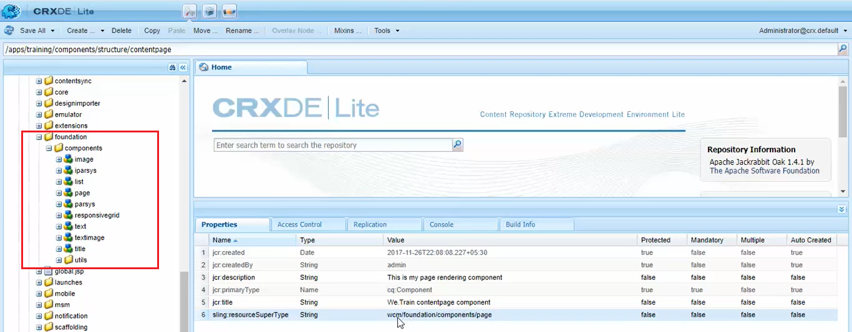

1. **image**
2. **iparsys**
3. **list**
4. **page**
5. **parsys**
6. **responsivegrid**
7. **text**
8. **testimage**
9. **title**

These are **all foundation AEM components** made in **Sightly** (with **file extension** as **HTML**).

Similarly, you can see all the **built-in AEM components** which are made in JSP (with file extension as JSP) in below path in **CRX/DE**: **/libs/foundation/components** (**not** under **wcm** folder)

Go to **AEM** --> **Sites** --> **We.Train** website --> **English** Page --> Click on **Edit** button at top.

It will open <http://localhost:4502/editor.html/content/we-train/en.html>

Click on **Open Properties** on toolbar --> you’ll see **dialog box** *listing* ***all the page properties*** (image below).

But we have **not** **defined** any **dialog box** for *page properties* within our **Page Rendering Component**.

**So how is it coming here?**

It is coming from built-in AEM **Page component** (/libs/wcm/**foundation**/components/page).

Because we have assigned below property to our Page Rendering component i.e. contentpage

|  |  |
| --- | --- |
| **Property** | **Value** |
| **sling:resourceSuperType** | wcm/foundation/components/page |

If you **remove** this above-mentioned **property** from *Properties Pane* and then **Click** on **Open properties**,

it will **not open** the **Properties *dialog box***.

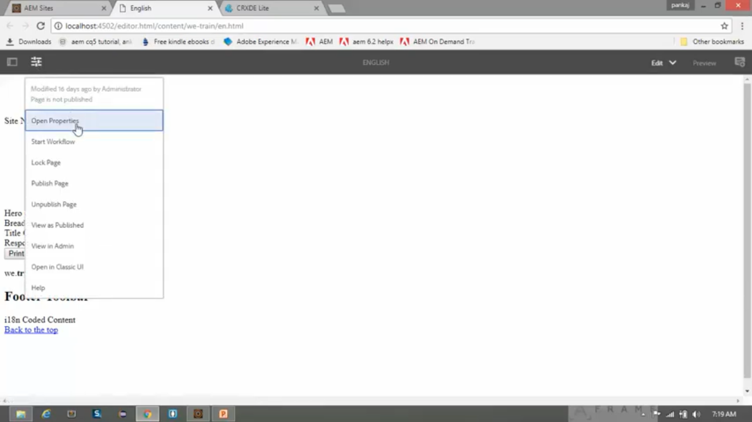

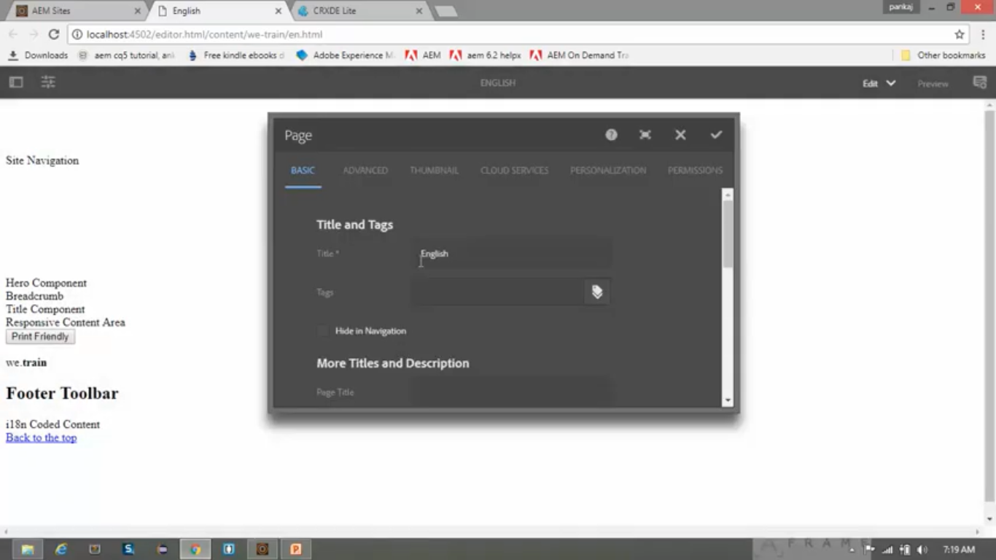

Let’s **delete** the **contentpage.html** file from **/apps/training/components/structure/contentpage** node.

Now open page <http://localhost:4502/editor.html/content/we-train/en.html>

Notice that this **page renders** just **fine** even ***without the default script*** (i.e. **contentpage.html**).

It **renders** **same as before** **deleting** the **contentpage.html**.

**How is that possible?**

This is because we have provided **sling:resourceSuperType** property **contentpage** component.

We have **deleted** the **HTML file** and **not** the **contentpage** component.

|  |  |
| --- | --- |
| **Property** | **Value** |
| **sling:resourceSuperType** | wcm/foundation/components/page |

The proper rendering of this page is possible, because **contentpage** component is **inheriting** a **number of scripts** from *built-in* AEM **Page component** (/libs/wcm/**foundation**/components/page).

While rendering the page, it performs following options:

* First, it **search** for its **default script** i.e. **contentpage.html**.
* Since we **deleted** **default script**, it will **search** for **sling:resourceSuperType** property of component.
* Since the **sling: resourceSuperType** property is pointing to the **wcm/foundation/components/page**, it will check built-in AEM **Page components *default script*** i.e. **page.html** inside page component i.e. at path **wcm/foundation/components/page/page.html**.
* Now inside this **page.html**, we have <data-sly-include=“body.html”>
* Now it will consider **body.html** from our **child** component (**contentpage** component) and **not** from **parent** component i.e. **wcm/foundation/components/page** component.
* If it **does not find** file named **body.html** in **child** component (**contentpage** component), *then only* it will **search** in **parent** component i.e. **wcm/foundation/components/page** component.

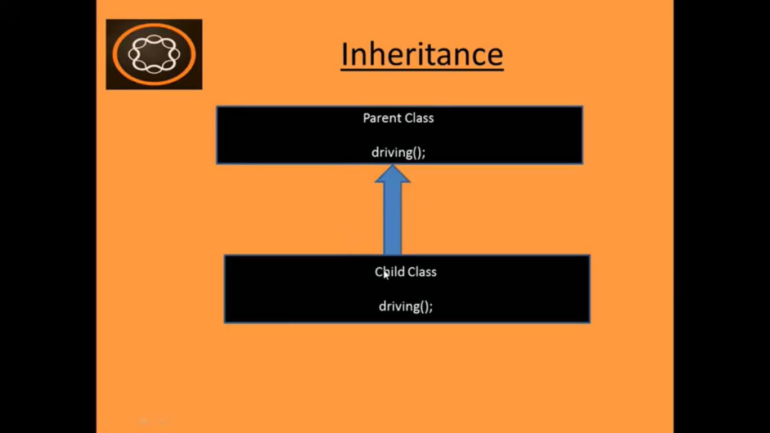

# 26. Client Library (Theory):

This section will explain about following:

1. What is **Client Library**?
2. **Why** it is used?
3. How to **reference** it?
4. What are the **properties** in client library?
5. **What is Client Library?**

It is used **to manage**the **client-side resources** (CSS, JS, images, fonts, etc).

1. **Why it is used?**

* **To keep all the client-side resources well organised** in project folders in the CRX repository.
* In today’s world, *complex websites are heavily dependent upon complex JS and CSS.*
* Maintaining and organising those files becomes very cumbersome and complex.
* That’s why AEM has introduced this concept of Client Library to keep them well organised.
* You can use **traditional HTML <SCRIPT> tag** as below in AEM:

<script type=“text/javascript” src=“script.js”>

* **But** above method can **lead to problems** *when page and its components becomes complex*
* In such cases, there is the ***danger that multiple copies of same JS may be included.***
* **Hence**, such syntax (**SCRIPT** tag) **should be avoided** in AEM applications and **Client library** should be **preferred** to organise client-side resources very well.

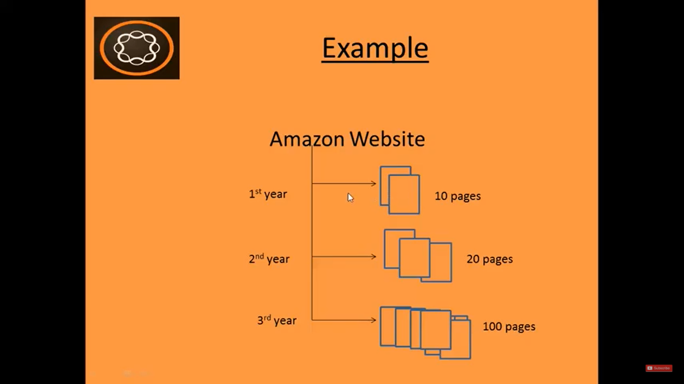

Consider an **example** of **Amazon website**.

There are 10 pages on 1st year, 20 pages on 2nd year and 100 pages on 3rd year.

In this case, there are chances that **same** JS or CSS files being used **multiple times**.

So, **Client Library** to be used **to avoid multiple references** of *client-side resources*.

1. **How to reference it?**

There are **3 ways to call** ClientLibraries using **data-sly-call** attribute.

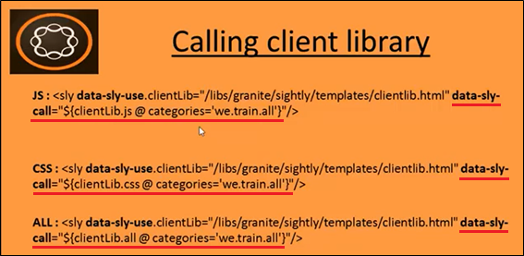

1. **What are the properties in client library?**

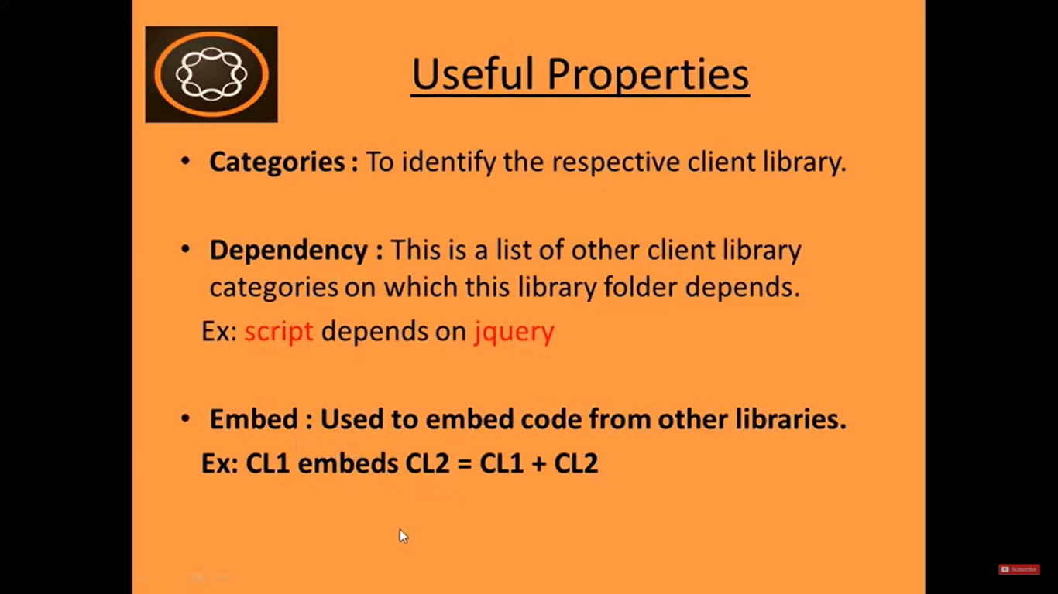

**Steps to create Client Library:**

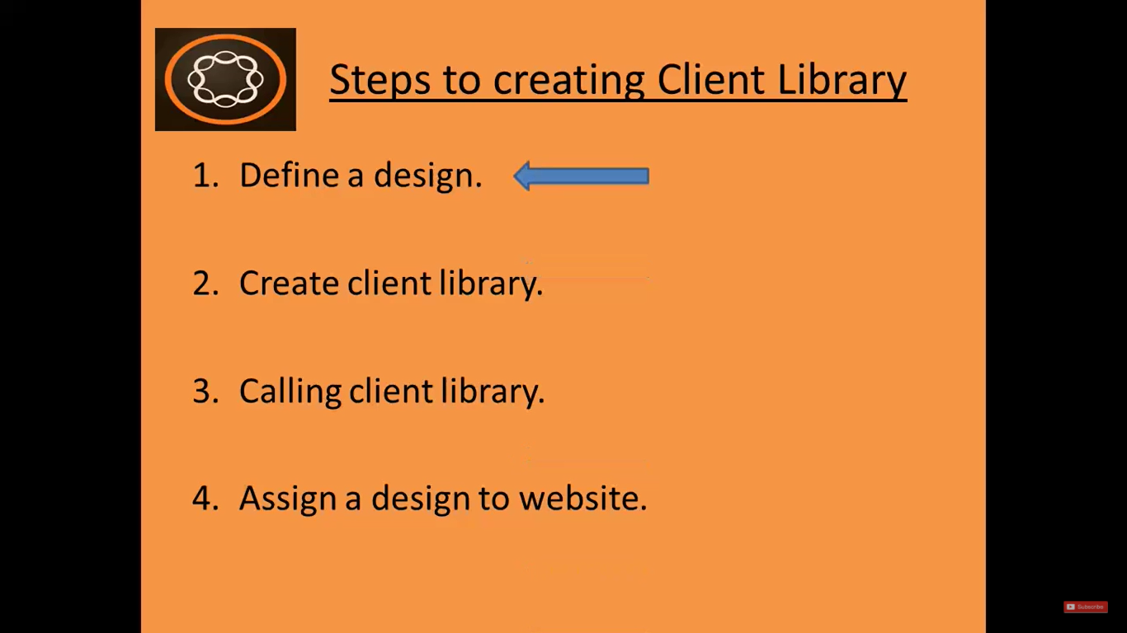

# 27. Define a design in AEM (Client Library – Part 1)

In AEM, **designs** are stored in **/etc/designs** folder.

Go to **AEM** (Landing page) --> **Tools** --> **Operations** --> **Configurations**.

It will open **Tools Console** or directly reach here by entering **URL:** <http://localhost:4502/miscadmin>

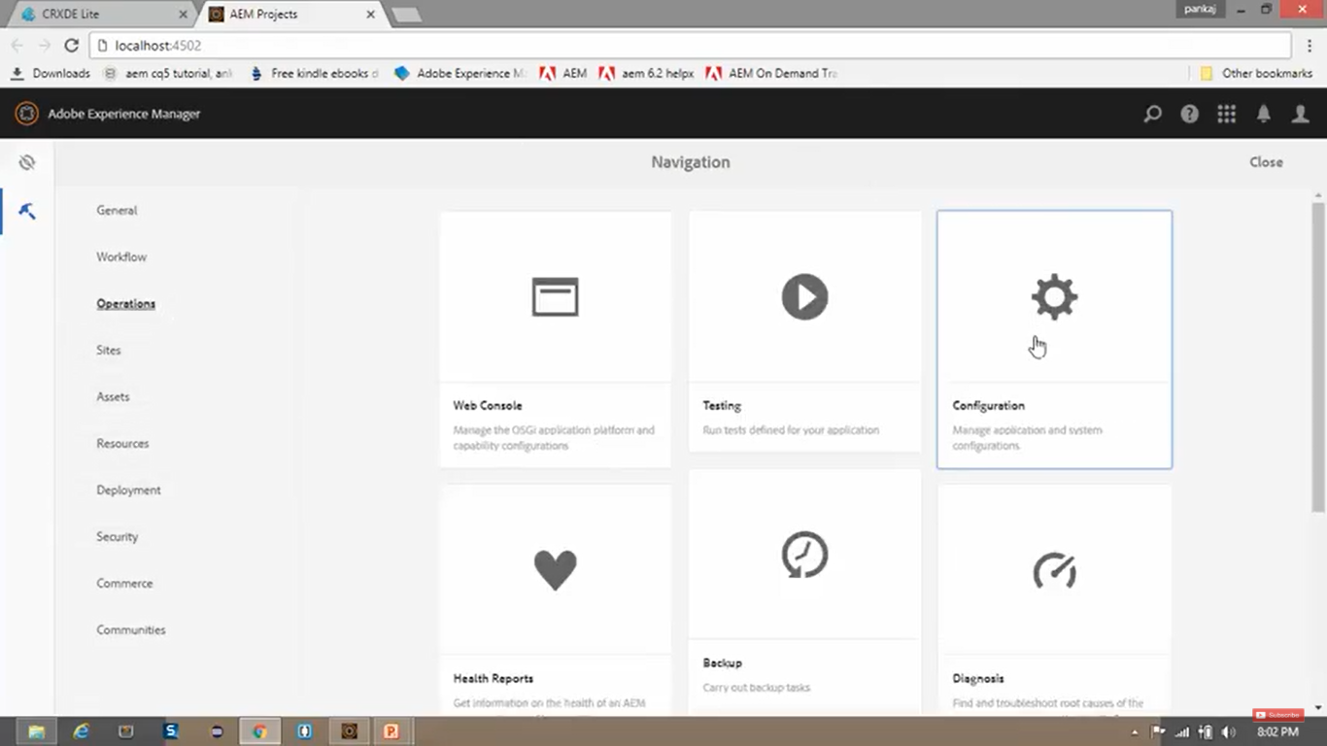

Now go to **Tools** folder --> **Designs** folder --> Click on **New** on Toolbar --> **New Page**

In **New Page** dialog box, enter below details:

|  |  |
| --- | --- |
| **Field** | **Value** |
| Title | We.Train.Designer |
| Name | training |

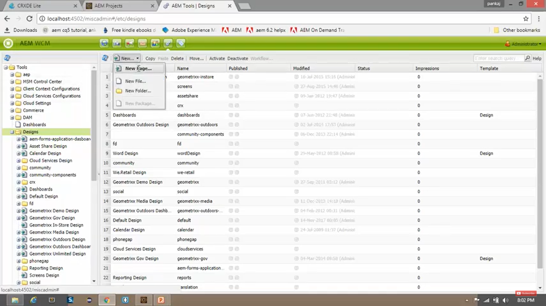

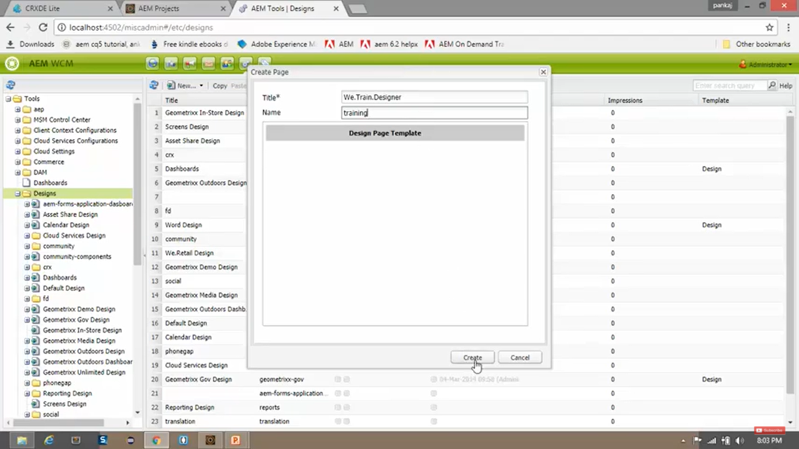

Click on **Create**. --> You can see in explorer view, **We.Retail Design** page has been created.

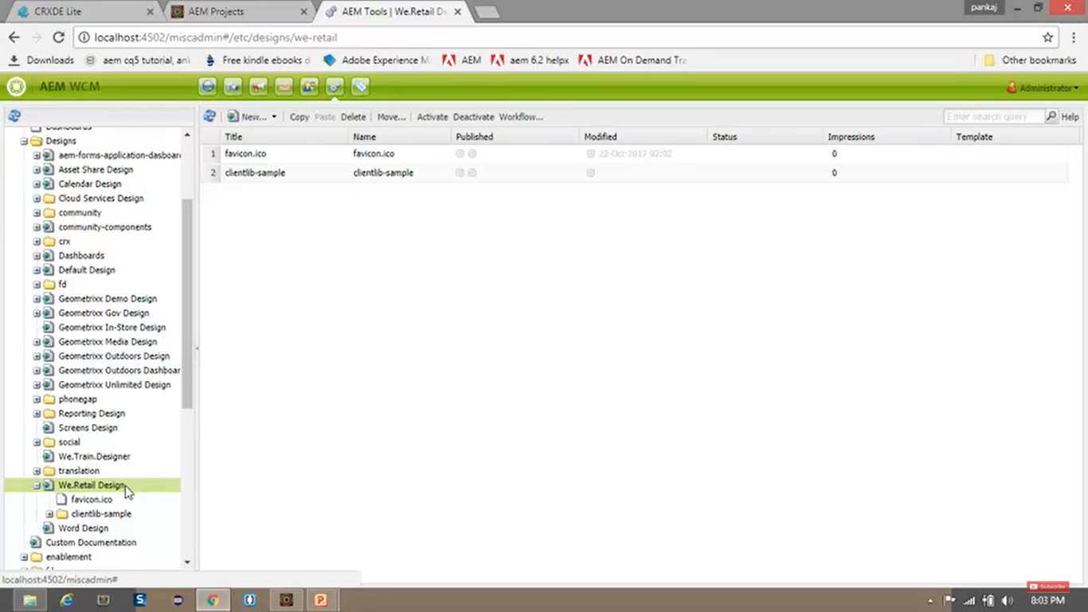

**Right click** on **CRX/DE** **/etc/designs** node --> Click on **Refresh** option.

Now you will find **new folder** named **training** is created under **/etc/designs** folder.

**Note** that the **type** *property* of **training** node is **cq:page.**

|  |  |  |
| --- | --- | --- |
| **Field Name** | **Type** | **Value** |
| jcr:primaryType | String | cq:page |

***Client Library*** path **/etc/designs/training** is where we will store our projects designs (client libraries).

The **Client Library** that make up look and feel of the site will be stored under the **/etc/designs** node.

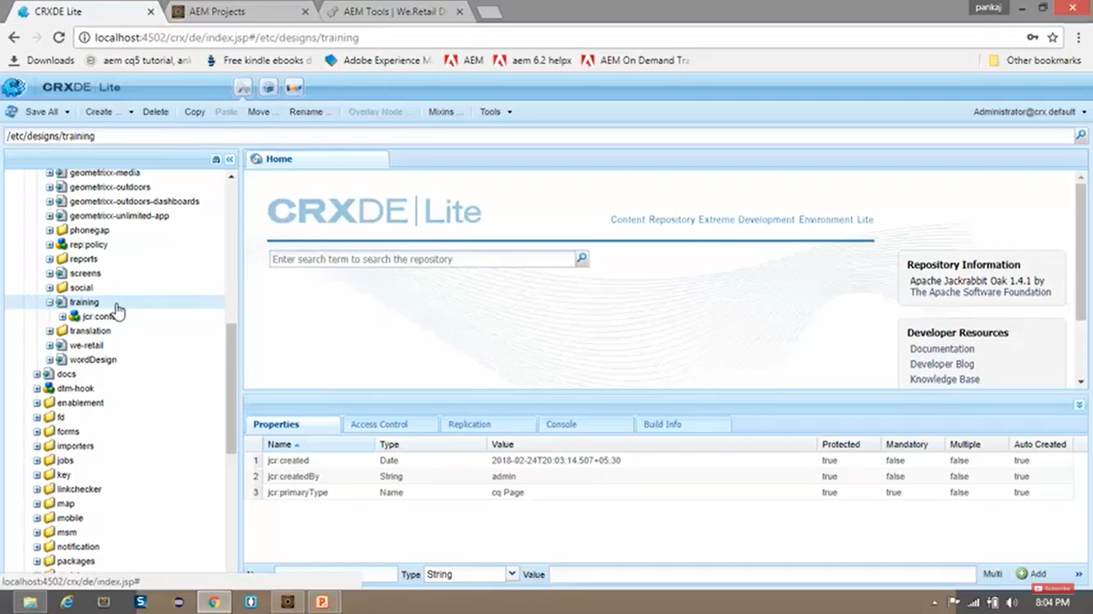

# 28. Create client library in AEM (Client Library – Part 2)

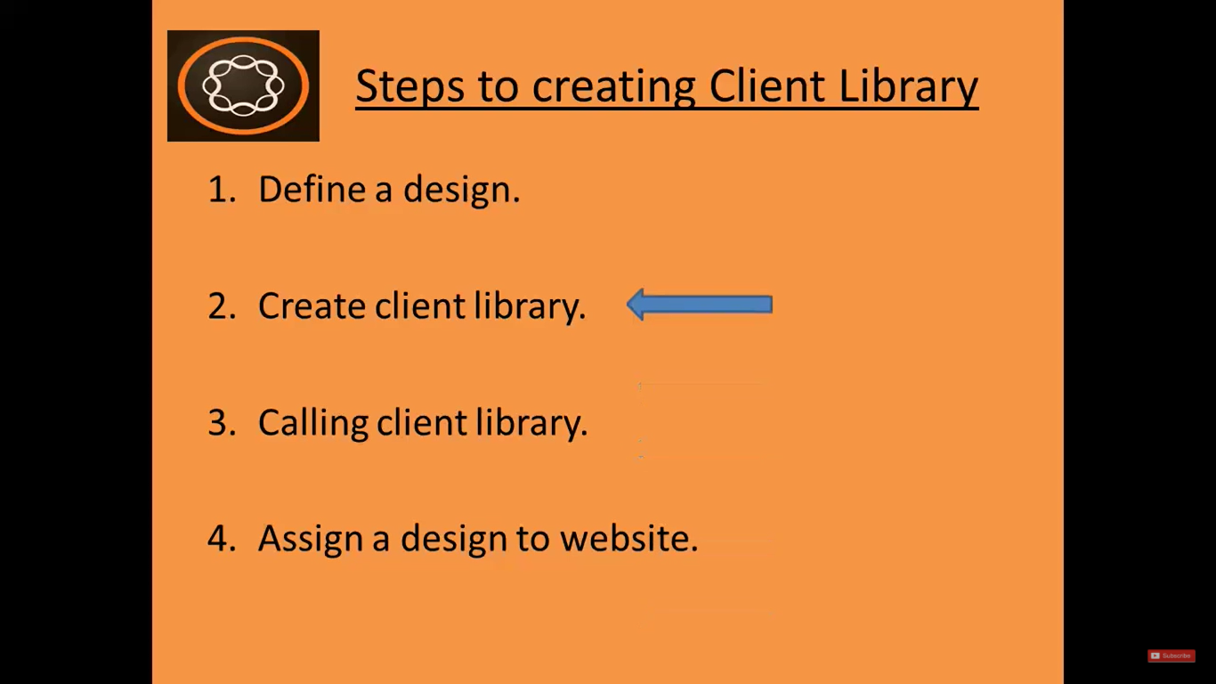

1. Let’s **Upload a package** where **Client Library** is already prepared.
2. Go to <https://github.com/pankajchhatri/AEM> --> [Developer course](https://github.com/pankajchhatri/AEM/tree/master/Developer%20course) --> [Chapter 9 Design and Styles](https://github.com/pankajchhatri/AEM/tree/master/Developer%20course/Chapter%209%20Design%20and%20Styles) --> [Task - Define Design](https://github.com/pankajchhatri/AEM/tree/master/Developer%20course/Chapter%209%20Design%20and%20Styles/Task%20-%20Define%20Design)
3. **Download** ZIP file **we-train-design-package.zip**.
4. Open **CRX Package manager** --> <http://localhost:4502/crx/packmgr>
5. Click on **Upload package** button --> Upload above package --> Click **OK** --> Click **Install** button.
6. In **Activity Log** **pane** at the bottom, you will see **79 nodes** saved under **/apps/training/temp** folder.
7. Go to **CRX/DE** path **/apps/training/temp** --> **Rename** 2 folders as below.

|  |  |
| --- | --- |
| **Initial Name** | **Modified Name** |
| Rename-clientlib-all | clientlib-all |
| Rename-clientlib-site | clientlib-site |

1. **Move** (**Cut** **+** **Paste**) these folders **clientlib-all** and **clientlib-site** into **/etc/designs/training** folder.
2. **Right click** on both the folders (nodes) --> Select **Move** --> Browse **/etc/designs/training** --> Click **OK**.

**Client Library** named ***clientlib-sites*** (node), contains folders containing individual types of client-side resources. These folders/resources are:

* CSS
* fonts
* images
* js

You can see 2 files as below with their following contents:

|  |  |  |
| --- | --- | --- |
| **File Name** | **File Contents** |  |
| css.txt | **#base=css** --> folder name  **style.css** --> file 1 name  **grid.less** --> file 2 name |  |
| js.txt | #base=js --> folder name  Script.js --> file 1 name |  |

The **clientlib-all** Client Library is created ***to list all the client libraries*** which the site requires.

Click **clientlib-all** --> set below 2 properties from its **properties pane**.

|  |  |  |
| --- | --- | --- |
| **Name** | **Type** | **Value** |
| Categories | String[] | we.train.all |
| Embed | String[] | we.train.site |

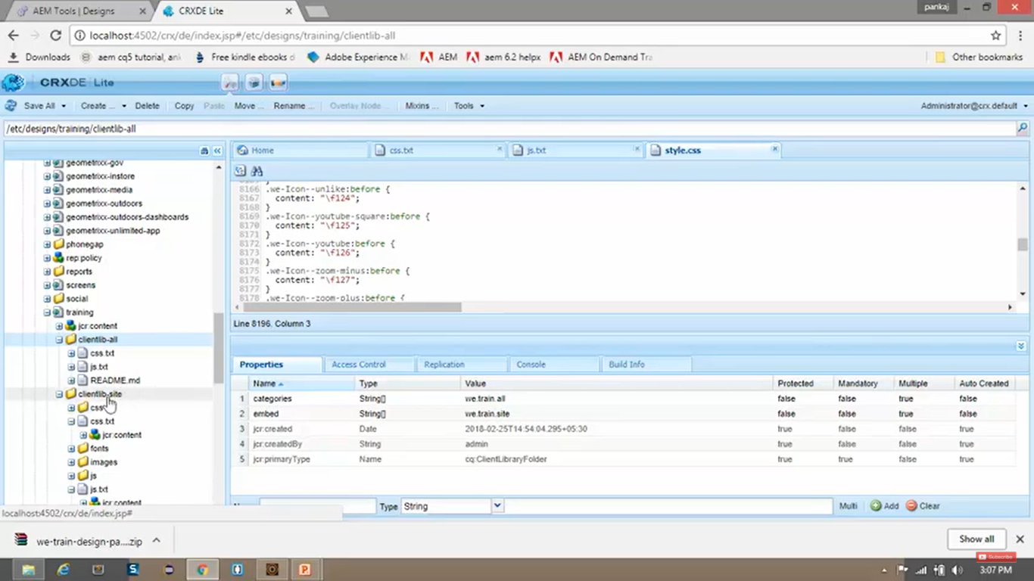

**If you want to create your own client library, then you need to perform below steps:**

**Right click** on **CRX/DE** node **/etc/designs/training** --> **Create** --> **Create Node** --> Enter below values

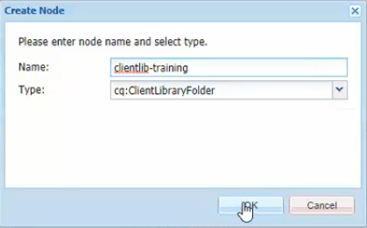

**Conclusion:** If you want to create your own **Client Library**, then create a node of **cq:ClientLibraryFolder** Type (as shown in above image)

# 29. Calling client library in AEM (Client Library – Part 3)

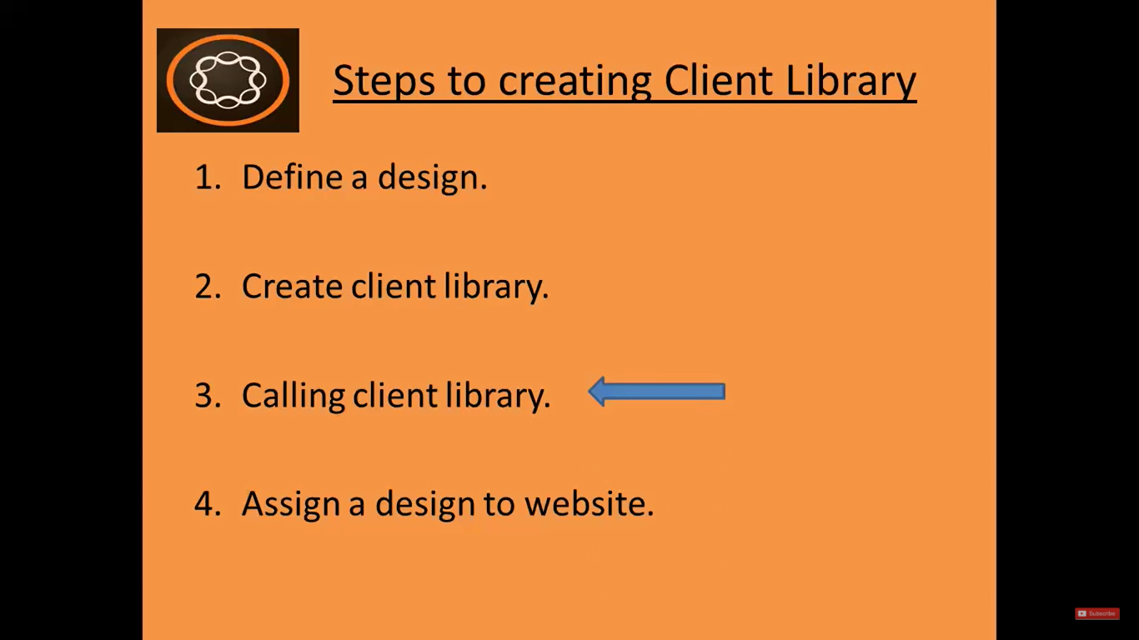

1. Go to **CRX/DE** path **/apps/training/components/structure/contentpage** --> **Right Click** on **contentpage** component node --> select **Create** --> select **Create File** --> (below 2 files)

* **customheaderlibs.html**
* **customfooterlibs.html**

1. Go to <https://github.com/pankajchhatri/AEM> --> [Developer course](https://github.com/pankajchhatri/AEM/tree/master/Developer%20course/Chapter%209%20Design%20and%20Styles/Task%20-%20Modify%20contentpage%20component%20to%20call%20the%20design) --> [Chapter 9 Design and Styles](https://github.com/pankajchhatri/AEM/tree/master/Developer%20course/Chapter%209%20Design%20and%20Styles/Task%20-%20Modify%20contentpage%20component%20to%20call%20the%20design) --> [Task – Modify contentpage component to call the design](https://github.com/pankajchhatri/AEM/tree/master/Developer%20course/Chapter%209%20Design%20and%20Styles/Task%20-%20Modify%20contentpage%20component%20to%20call%20the%20design)
2. **Copy** the **contents** of the **files** from this path to our path

* **customheaderlibs.html** (To provide reference to **CSS** files --> Best practice to call at start of page)

<!--/* Include the site client libraries (loading only the CSS in the header, JS will be loaded in the footer) */-->

<sly data-sly-use.clientLib="/libs/**granite**/sightly/templates/clientlib.html" data-sly-call="${clientLib.css @ categories='we.train.all'}" />

Here we are calling client library whose name is **we.train.all** (which we create in section 27) from **customheaderlibs.html**.

“categories” attribute is used to identify the client library.

We are using **data-sly-use** attribute to specify reference to the template, and we are getting the reference into data-sly-use.clientlib object.

With **data-sly-call** attribute, using this reference stored in above clientlib object we are calling **css** files of this client library.

* **customfooterlibs.html** (To provide reference to **JS** files --> Best practice to call at end of page)

<!--/* Include the site client libraries (loading only the JS in the footer, CSS was loaded in the header) */-->

<sly data-sly-use.clientLib="/libs/**granite**/sightly/templates/clientlib.html" data-sly-call="${clientLib.js @ categories='we.train.all'}"/>

Just like above using “clientlib” object we are calling **JS** files of this client library.

Open /apps/training/components/structure/contentpage/footer.html

Add below code to insert footer **customfooterlibs.html** file

<sly **data-sly-include** = “customfooterlibs.html”>

**NOTE:** We will **NOT** add code to insert **customheaderlibs.html** in **header.html.** (reason at next)

Because, when we request for our page, it will check for page’s template. i.e. in our case it is **contentpage** template.

Here it will look for ***default page name*** i.e. **contentpage.html**.

Since this default page is not available, it will search for parent element (**resourceSuperType** property of the **contentpage** template) which is set to **wcm/foundation/components/page**

So, in this page component it will search for default page name i.e. “page.html”.

Path of this page is **/libs/wcm/ foundation/components/page/page.html**.

The **contents** of this **page.html** is as below:

<html>

<head **data-sly-include**=“head.html”> </head>

<body **data-sly-include**=“body.html”> </body>

</html>

Here, it will consider **body.html** from our component, **but** our component **doesn’t** contain **head.html**.

So, it will consider **head.html** from wcm page component itself having path **/libs/wcm/ foundation/components/page/head.html**.

In **/libs/wcm/ foundation/components/page/head.html** file, it already using **customheaderlibs.html**

<sly **data-sly-include** = “customheaderlibs.html”>

That is the reason why we **did** **not** add code to insert **customheaderlibs.html** in **header.html.**

# 30. Assign a design to a website in AEM (Client Library – Part 4)

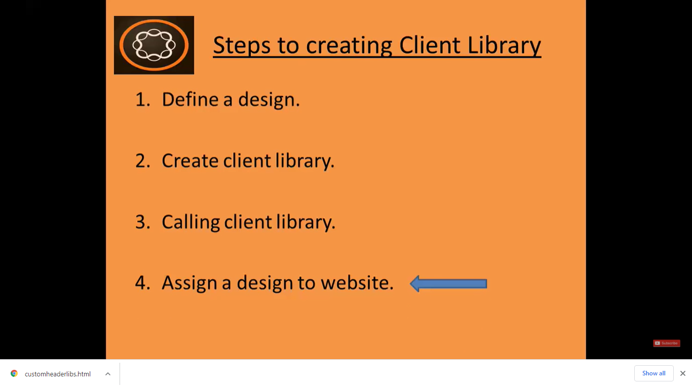

Go **AEM** --> **Sites** --> Click on website **We.Train** --> Click **View Properties** on Toolbar --> **Advanced** tab -->

In **Design** field --> Select the design created earlier named **We.Train** **Designer** --> Click **OK**  --> Click **Save**

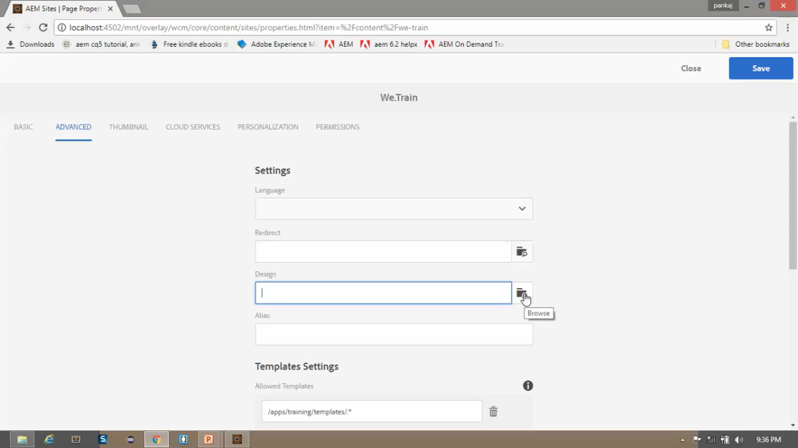

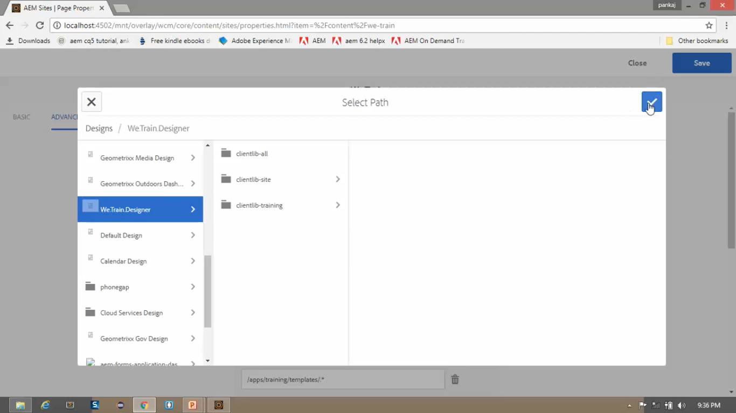

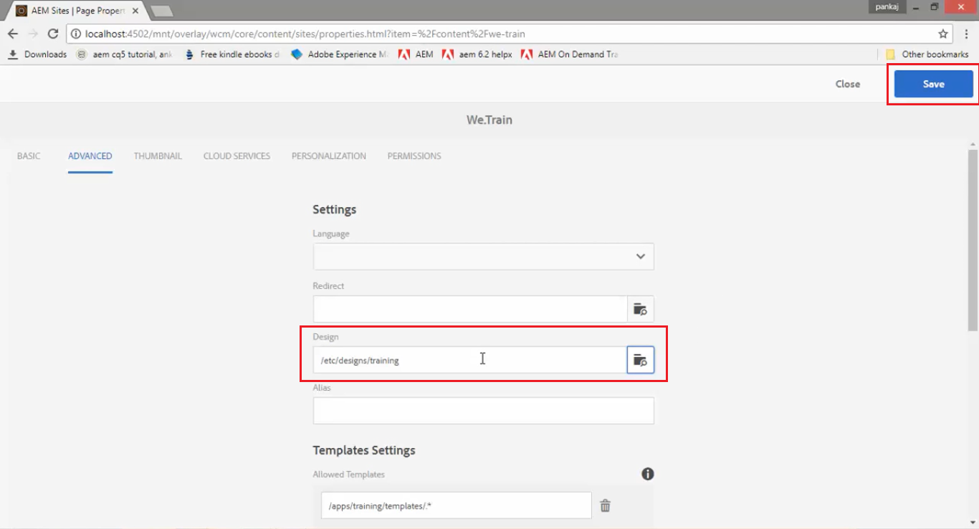

Go **AEM** --> **Sites** --> Click on website **We.Train** --> Click on **English** Page --> Click on **Edit** button on Toolbar.

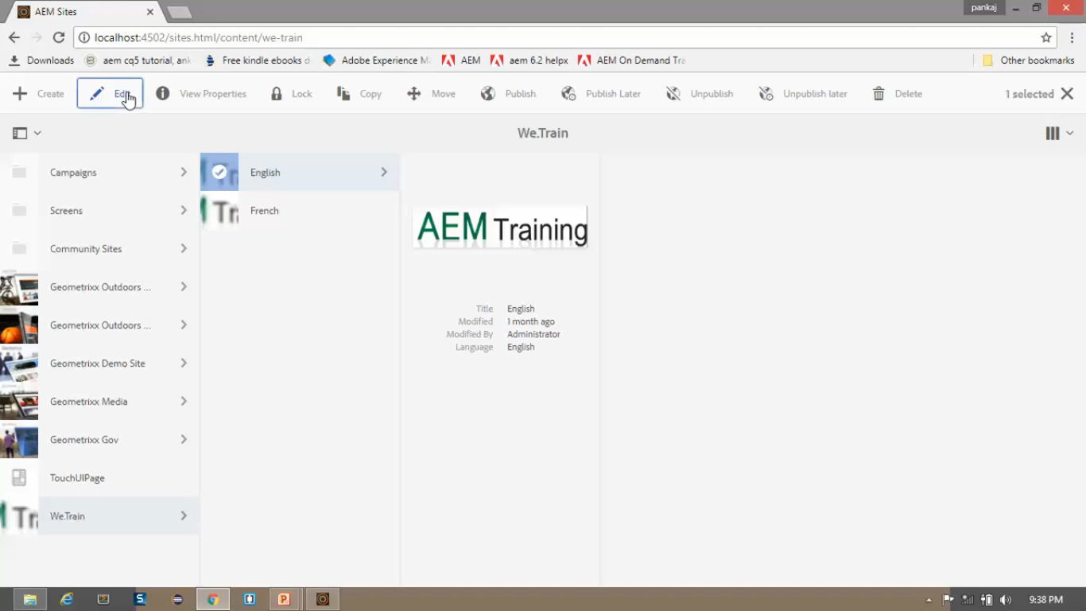

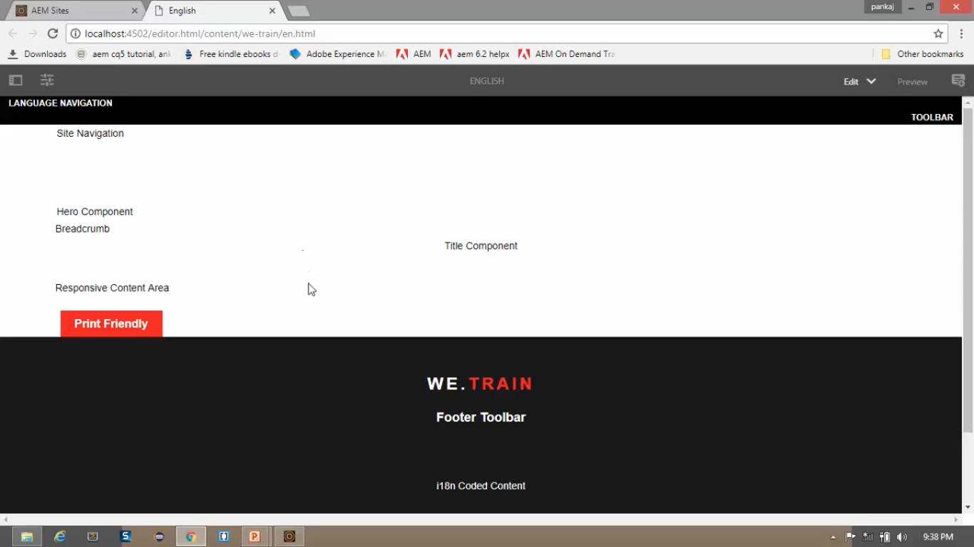

Notice that **English** page has inherited the design from **We.Train** website root.

Now **each page** of the **website** is using **newly defined design** and **updated look and feel** because of the **Client Library** we created.

# 31. Creating simple Navigation Component

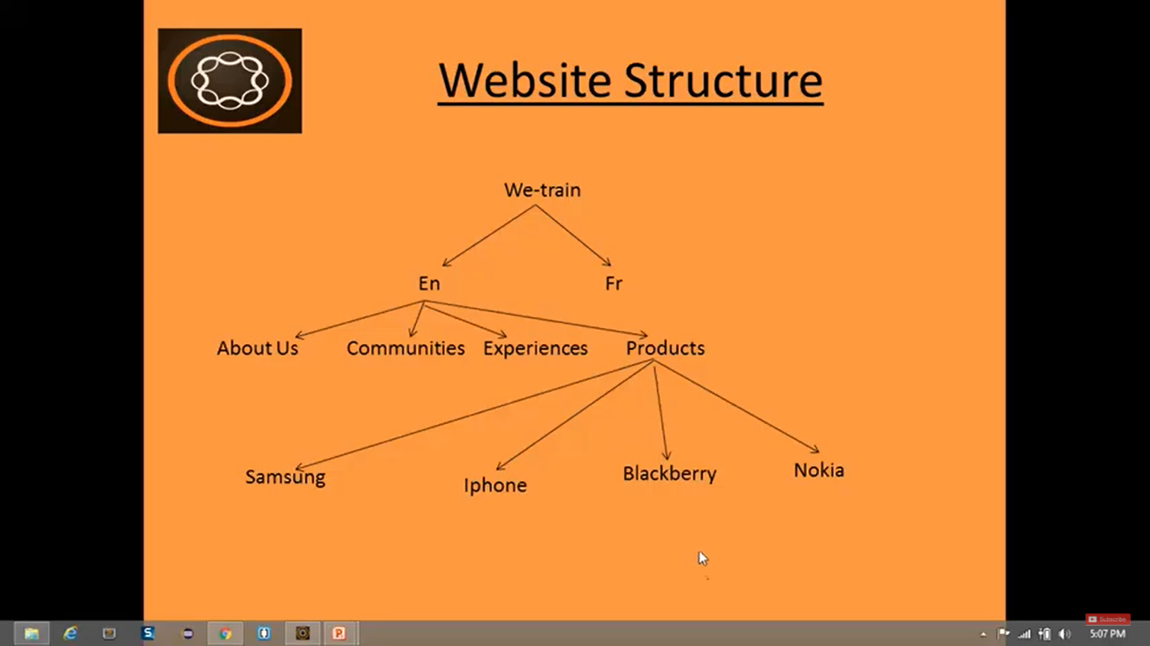

1. Some of the **navigation menus** (like Products) will have **sub-menus**.
2. Some of the **navigation menus** (like About us, Communities, Experiences) **does not** have **sub-menus**.
3. Hence, ***to overcome this issue***, we need to create **Complex** **Navigation Component**, which we will **create** in **next section**.
4. But here, we’ll create a **Simple** **Navigation Component**, which will **show child page of current page**.
5. If **current** page (for example, Nokia), **does not** have a **child** page, then it will **show as blank**.

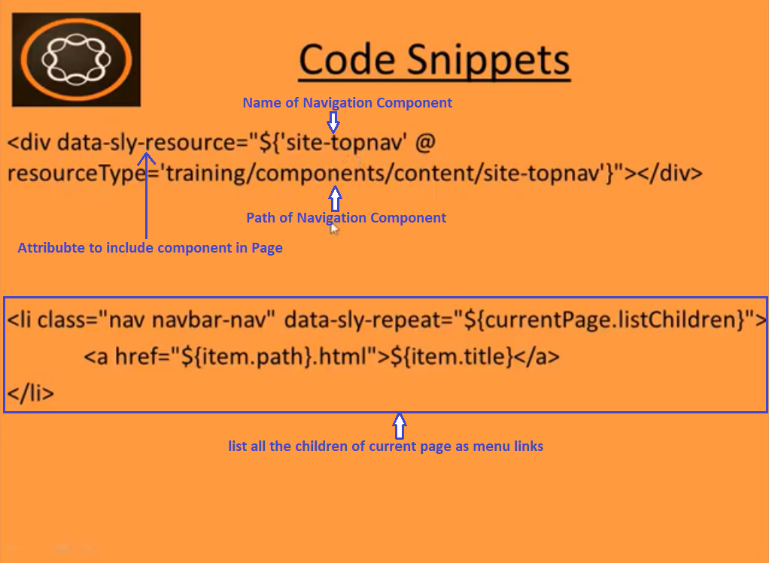

1. Go to **CRX/DE** path **/apps/training/components/content**.
2. Now, *we will create* ***Site Navigation*** *component in this folder*.
3. **Right click** on **/apps/training/components/content** --> **Create** --> Create **Component** --> below values

|  |  |
| --- | --- |
| **Field** | **Value** |
| Label | Site-topnav |
| Title | Top Navigation |

1. Keep other fields **<blank>** --> Click **Next** button --> Keep other fields as it is **untouched** --> Click **OK**.
2. Go to **CRX/DE** path **/apps/training/components/content/site-topnav/site-topnav.jsp**
3. To create **HTL/Sightly** syntax --> **Rename** this **site-topnav.jsp** to **site-topnav.html**.
4. Go to <https://github.com/pankajchhatri/AEM> --> [Developer course](https://github.com/pankajchhatri/AEM/tree/master/Developer%20course/Chapter%2010%20Authoring%20Structure%20Components/Lab%20Activity%20-%20I/Task%201%20-%20Create%20a%20simple%20navigation%20component) --> [Chapter 10 Authoring Structure Components](https://github.com/pankajchhatri/AEM/tree/master/Developer%20course/Chapter%2010%20Authoring%20Structure%20Components/Lab%20Activity%20-%20I/Task%201%20-%20Create%20a%20simple%20navigation%20component) --> [Lab Activity - I](https://github.com/pankajchhatri/AEM/tree/master/Developer%20course/Chapter%2010%20Authoring%20Structure%20Components/Lab%20Activity%20-%20I/Task%201%20-%20Create%20a%20simple%20navigation%20component) --> [Task](https://github.com/pankajchhatri/AEM/tree/master/Developer%20course/Chapter%2010%20Authoring%20Structure%20Components/Lab%20Activity%20-%20I/Task%201%20-%20Create%20a%20simple%20navigation%20component) 1 - Create a simple navigation component
5. Copy contents of **site-topnav.html** into our component **site-topnav.html**. Click on **Save** button.
6. Here **site-topnav.html** contains below code which we discussed earlier.

<ul class="nav navbar-nav navbar-center">

<li class="nav navbar-nav navbar-left" data-sly-repeat="${currentPage.listChildren}">

<a href="${item.path}.html">${item.title}</a>

</li>

</ul>

1. Now we will include this **site-topnav.html** component in our **Page Rendering** Component i.e. our **contentpage** component inside its child node **header.html**.
2. In **/apps/training/components/structure/header.html** replace below text with above code.

|  |  |
| --- | --- |
| **Head.html content** | **Replace with code reference to simple site navigation component** |
| <div> Site navigation </div> | <div data-sly-resource="${'site-topnav' @ resourceType='training/components/content/site-topnav'}"></div> |



Kindly refer **below screenshots** for **UI** for newly created **Simple Navigation Component**.

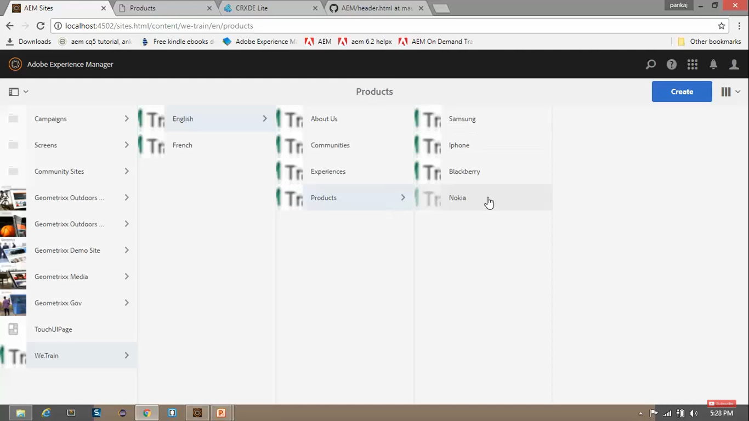

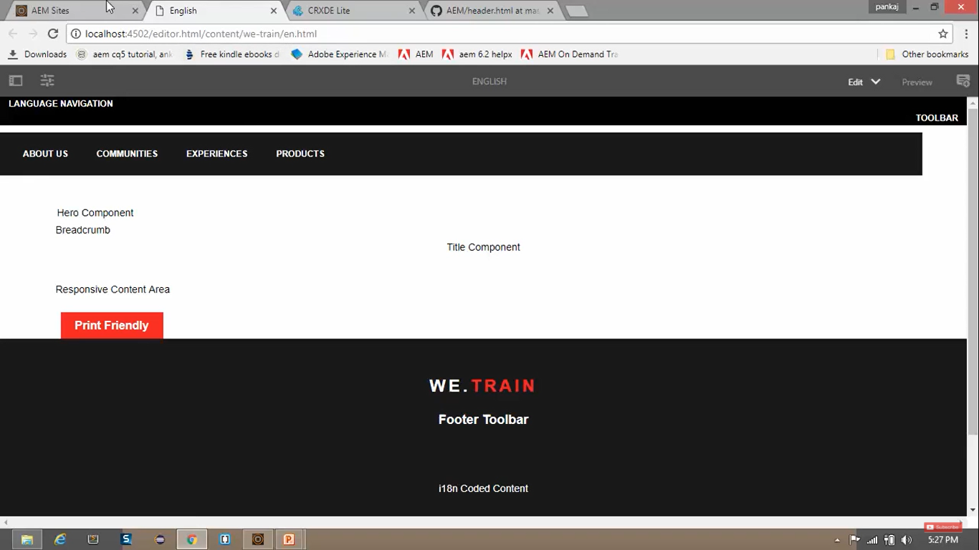

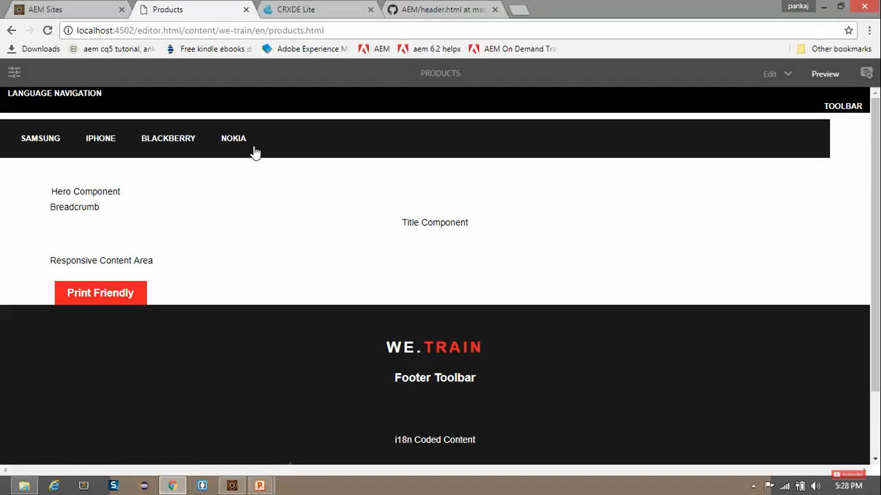

# 32. Responsive Navigation Component (using bootstrap classes)

* In last section, we have created a **Simple Navigation Component**, but it is not Responsive.
* We can see (image below), that if we **reduce the size** of **Browser Window**, our **Navigation** will **break**.
* That’s why, *in this section*, we will **make it responsive**.

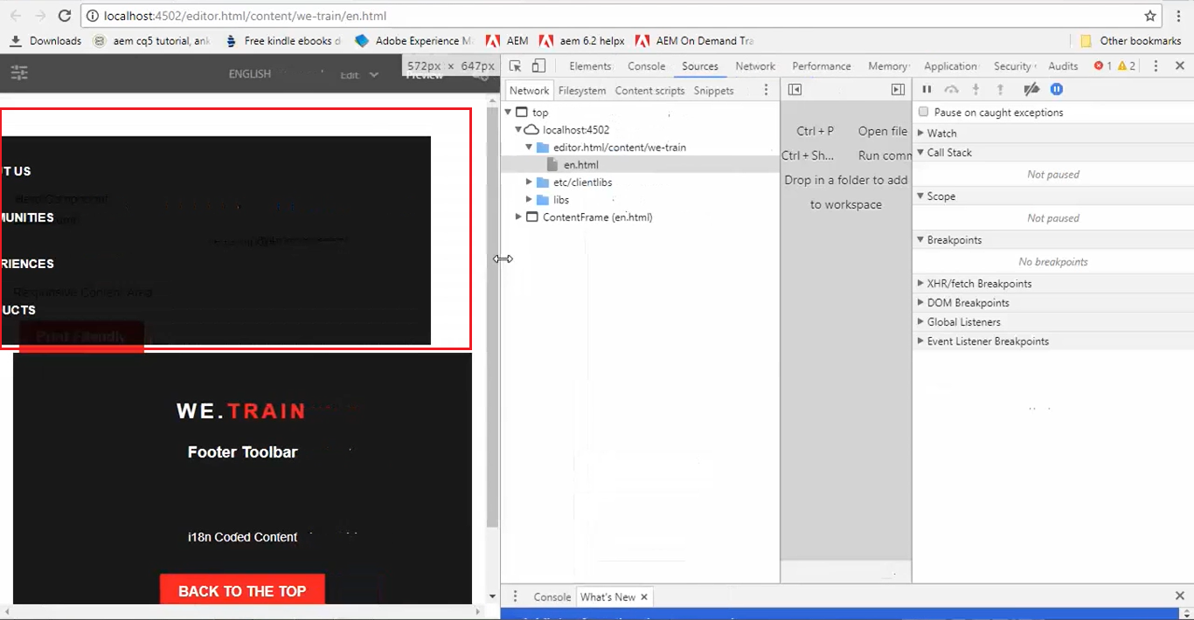

1. Go to <https://github.com/pankajchhatri/AEM> --> [Developer course](https://github.com/pankajchhatri/AEM/tree/master/Developer%20course/Chapter%2010%20Authoring%20Structure%20Components/Lab%20Activity%20-%20I/Task%202%20-%20Make%20the%20navigation%20component%20responsive) --> [Chapter 10 Authoring Structure Components](https://github.com/pankajchhatri/AEM/tree/master/Developer%20course/Chapter%2010%20Authoring%20Structure%20Components/Lab%20Activity%20-%20I/Task%202%20-%20Make%20the%20navigation%20component%20responsive) --> [Lab Activity - I](https://github.com/pankajchhatri/AEM/tree/master/Developer%20course/Chapter%2010%20Authoring%20Structure%20Components/Lab%20Activity%20-%20I/Task%202%20-%20Make%20the%20navigation%20component%20responsive) --> [Task 2 - Make the navigation component responsive](https://github.com/pankajchhatri/AEM/tree/master/Developer%20course/Chapter%2010%20Authoring%20Structure%20Components/Lab%20Activity%20-%20I/Task%202%20-%20Make%20the%20navigation%20component%20responsive)
2. Go to **CRX/DE** path **/apps/training/components/content**.
3. Copy contents of **site-topnav.html** into our component **site-topnav.html**. Click on **Save** button.
4. The **code** for *generating* **Navigation Elements** is the **same**.
5. Except that code, **extra DIVs** and **CSS** is *added* to make the **Navigation Component** *responsive*.

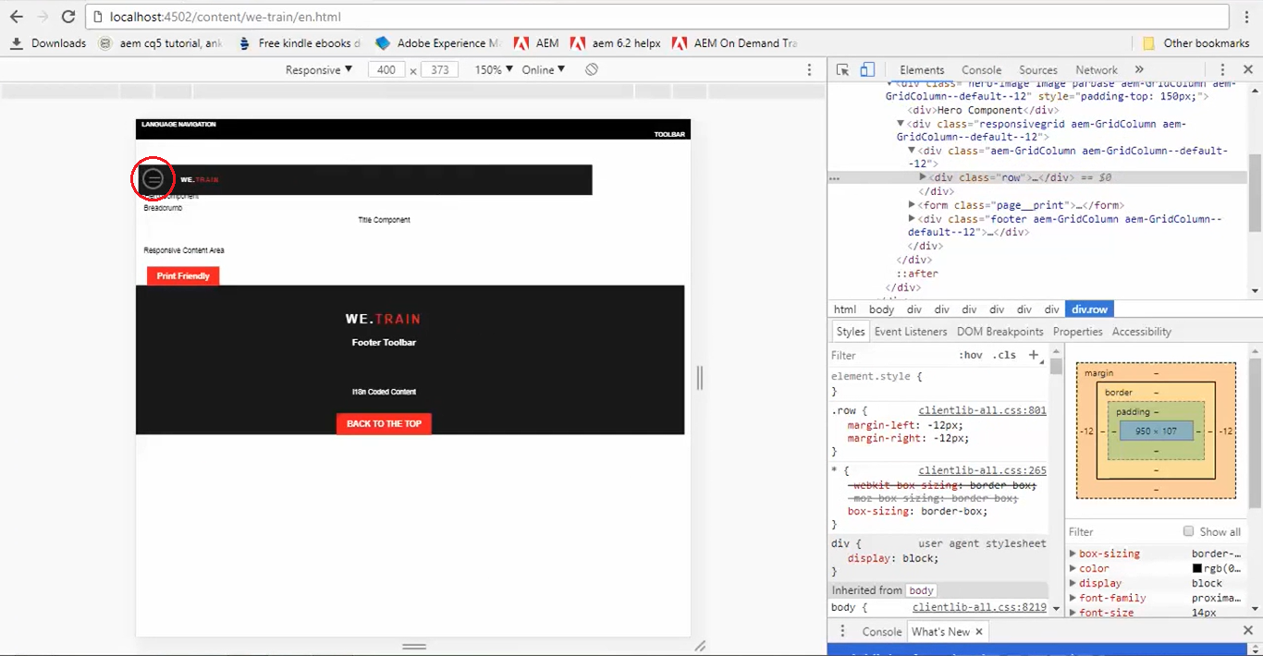

Now, we can see (image above), that if we **reduce the size** of **Browser Window**, **Navigation** isn’t **breaking**.

We made it **responsive**. Click on **Menu** icon **to** **expand** the **Navigation Bar** which displays **Navigation Links**

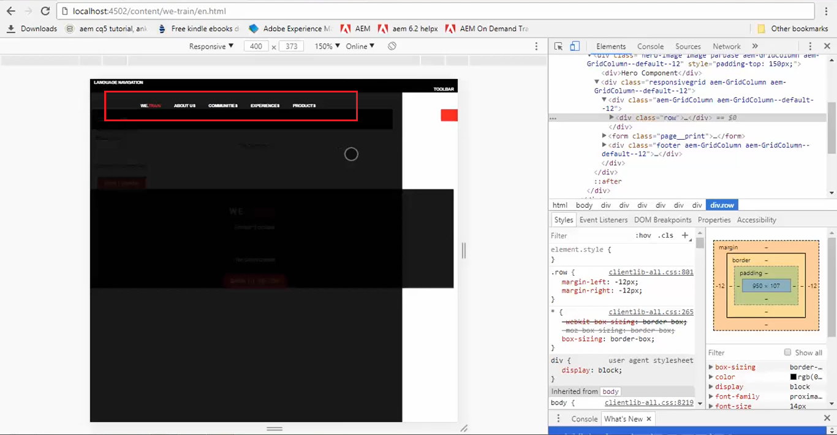

# 33. Creating Complex Navigation component using Java Helper in AEM

**Blackberry** Page has **no children** so it will show a page with **empty navigation** i.e. **without any links**.

(below image)

So, the **Simple Navigation Component** will **not work** because **Navigation Links** need to be **same and consistent** on **all pages**. Hence, we will develop **Complex Navigation** in this section.

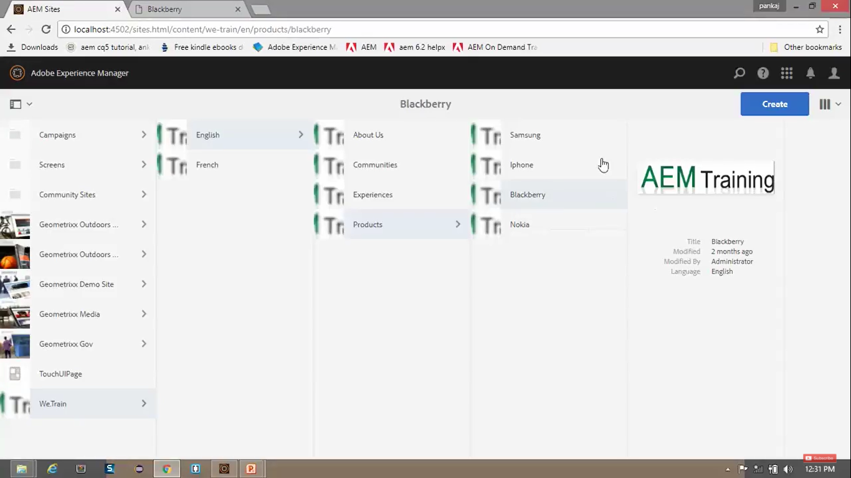

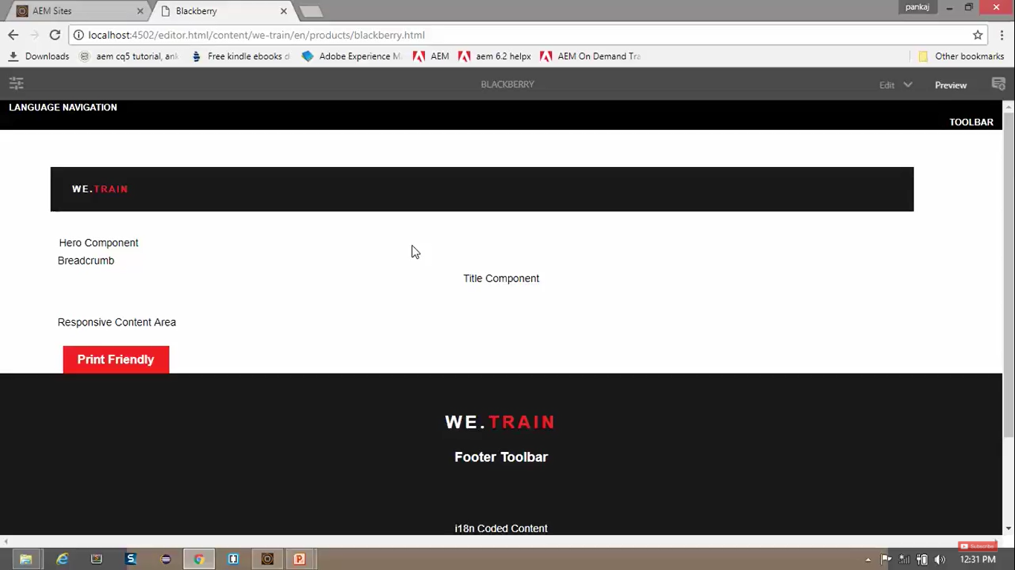

1. We will use **Java Helper** to perform some business logic to construct Complex Navigation Menu.
2. WE will be using **WCM POJO class** and we can also use **sling models** which are used in AEM **6.3** nowadays. We can use **sling models** in AEM **6.2** too.
3. Go to **CRX/DE** path **/apps/training/components/content/site-topnav**.
4. Right Click on **/apps/training/components/content/site-topnav** node --> Create --> Create **File** -->Name it **TopNav.java** --> Click **OK**
5. Go to <https://github.com/pankajchhatri/AEM> --> [Developer course](https://github.com/pankajchhatri/AEM/tree/master/Developer%20course/Chapter%2010%20Authoring%20Structure%20Components/Lab%20Activity%20-%20I/Task%203%20-%20Create%20a%20complex%20navigation%20component%20with%20Java%20Helper) --> [Chapter 10 Authoring Structure Components](https://github.com/pankajchhatri/AEM/tree/master/Developer%20course/Chapter%2010%20Authoring%20Structure%20Components/Lab%20Activity%20-%20I/Task%203%20-%20Create%20a%20complex%20navigation%20component%20with%20Java%20Helper) --> [Lab Activity - I](https://github.com/pankajchhatri/AEM/tree/master/Developer%20course/Chapter%2010%20Authoring%20Structure%20Components/Lab%20Activity%20-%20I/Task%203%20-%20Create%20a%20complex%20navigation%20component%20with%20Java%20Helper) --> Task 3 - Create a complex [navigation](https://github.com/pankajchhatri/AEM/tree/master/Developer%20course/Chapter%2010%20Authoring%20Structure%20Components/Lab%20Activity%20-%20I/Task%203%20-%20Create%20a%20complex%20navigation%20component%20with%20Java%20Helper) component with Java Helper
6. **Copy** contents of **TopNav.java** into our **TopNav.java**. Click on **Save** button.
7. Also **Copy** contents of **site-topnav.html** into our component **site-topnav.html**. Click on **Save** button.
8. Check highlighted texts in **site-topnav.html** file from screenshots for **difference** with **previous version**.

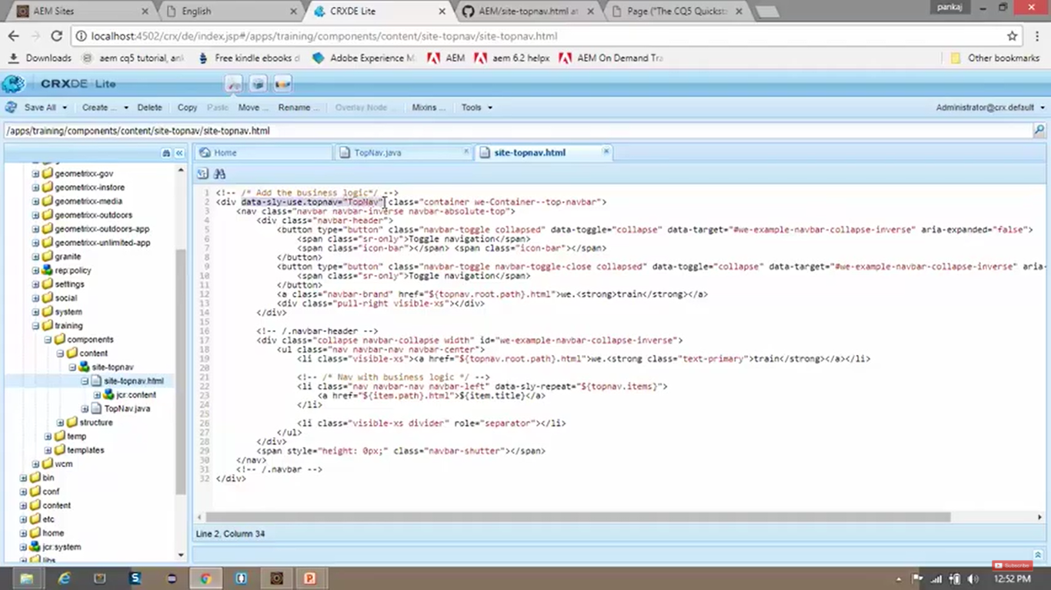

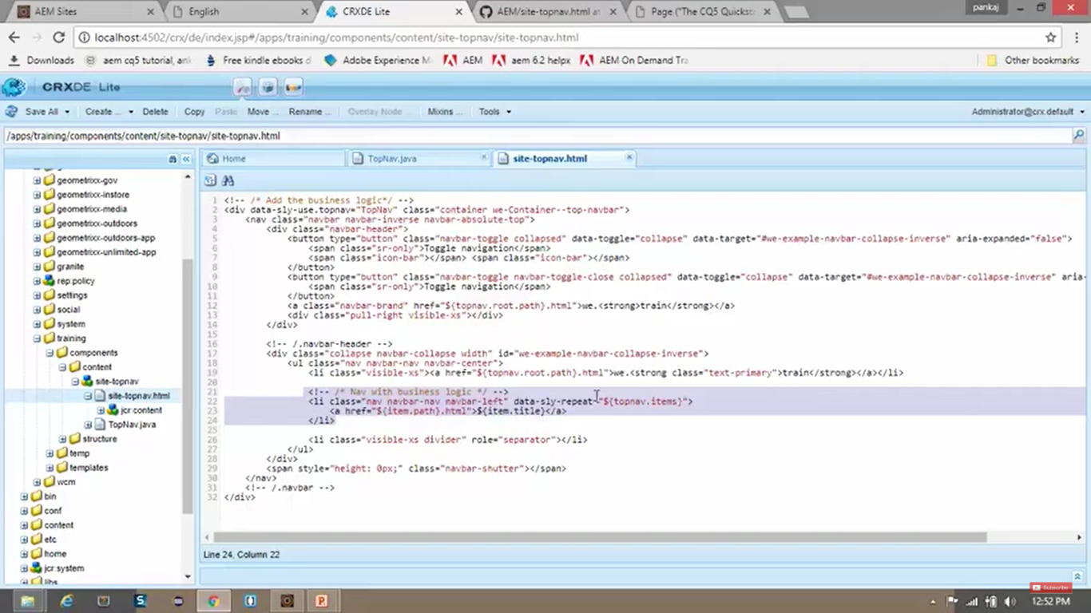

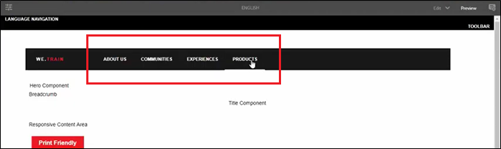

# 34. Creating Complex Navigation component using JavaScript Helper in AEM

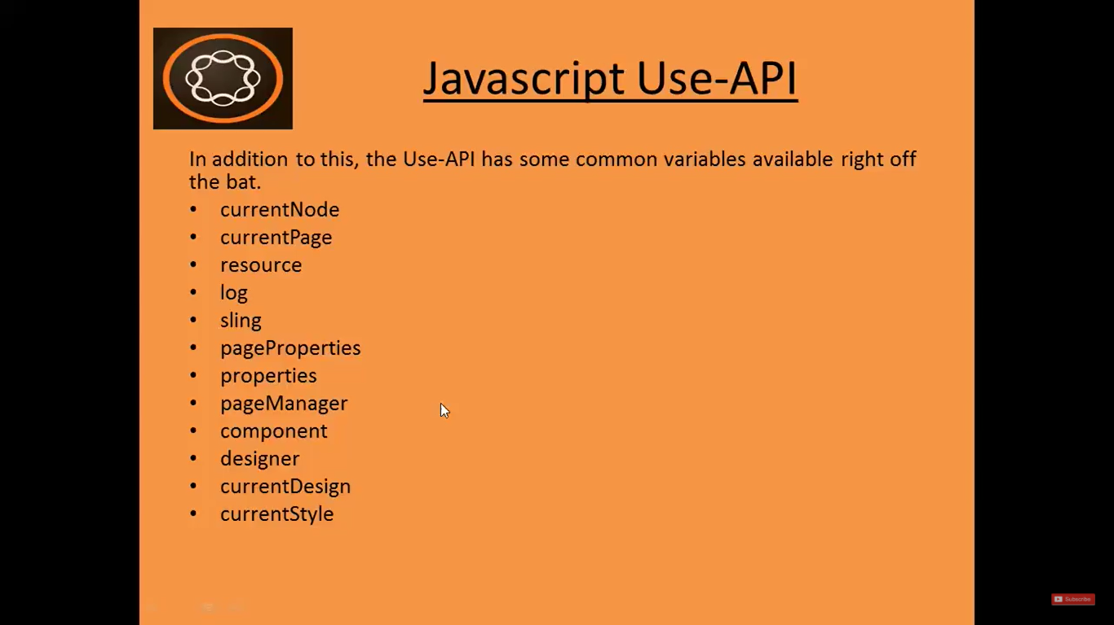

Above mentioned APIs are already available in javascript Use-API in AEM.

1. Go to **CRX/DE** path **/apps/training/components/content/site-topnav**.
2. Right Click on **/apps/training/components/content/site-topnav** node--> **Create** --> Create **File** -->Name it **TopNav.js** --> Click **OK**
3. Go to <https://github.com/pankajchhatri/AEM> --> [Developer course](https://github.com/pankajchhatri/AEM/tree/master/Developer%20course/Chapter%2010%20Authoring%20Structure%20Components/Lab%20Activity%20-%20I/Task%203%20-%20Create%20a%20complex%20navigation%20component%20with%20Java%20Helper) --> [Chapter 10 Authoring Structure Components](https://github.com/pankajchhatri/AEM/tree/master/Developer%20course/Chapter%2010%20Authoring%20Structure%20Components/Lab%20Activity%20-%20I/Task%203%20-%20Create%20a%20complex%20navigation%20component%20with%20Java%20Helper) --> [Lab Activity - I](https://github.com/pankajchhatri/AEM/tree/master/Developer%20course/Chapter%2010%20Authoring%20Structure%20Components/Lab%20Activity%20-%20I/Task%203%20-%20Create%20a%20complex%20navigation%20component%20with%20Java%20Helper) --> [Task 4 - Complex navigation component with JavaScript Helper](https://github.com/pankajchhatri/AEM/tree/master/Developer%20course/Chapter%2010%20Authoring%20Structure%20Components/Lab%20Activity%20-%20I/Task%204%20-%20Complex%20navigation%20component%20with%20JavaScript%20Helper)
4. Copy contents of **TopNav.js** into our **CRX/DE** **TopNav.js**. Click on **Save** button.
5. This file has the **same logic** that we had in **TopNav.java** class.
6. Also **Copy** contents of **site-topnav.html** into our component **site-topnav.html**. Click on **Save**.
7. Check text in **line number 1** for **difference** in **site-topnav.html** file with respect to its **previous version**.

|  |  |
| --- | --- |
| Previous version | Current version |
| <div data-sly-use.topnav="TopNav.java" class="container we-Container--top-navbar"> | <div data-sly-use.topnav="topnav.js" class="container we-Container--top-navbar"> |

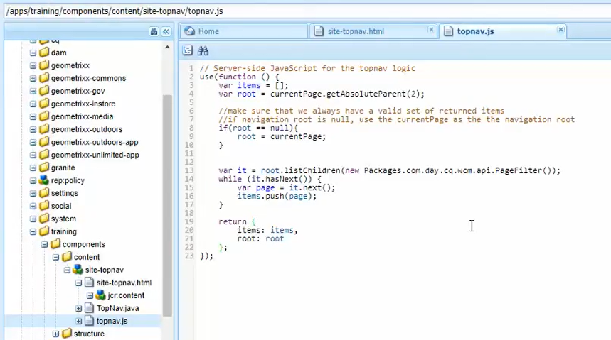

**OUTPUT** remains same as earlier



# 35. Introduction to Logs in AEM

* **Log** is a **file of events** that are logged by applications.
* When you **install** the **AEM instance** first time, it creates a **folder** named **crx-quickstart**.
* Go inside **crx-quickstart/logs** folder. The **files** inside this folder are **default AEM log files** which are created **out of the box** when you **start** an AEM instance.

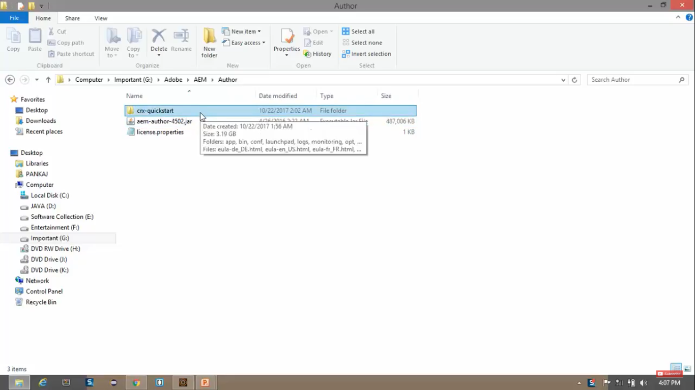

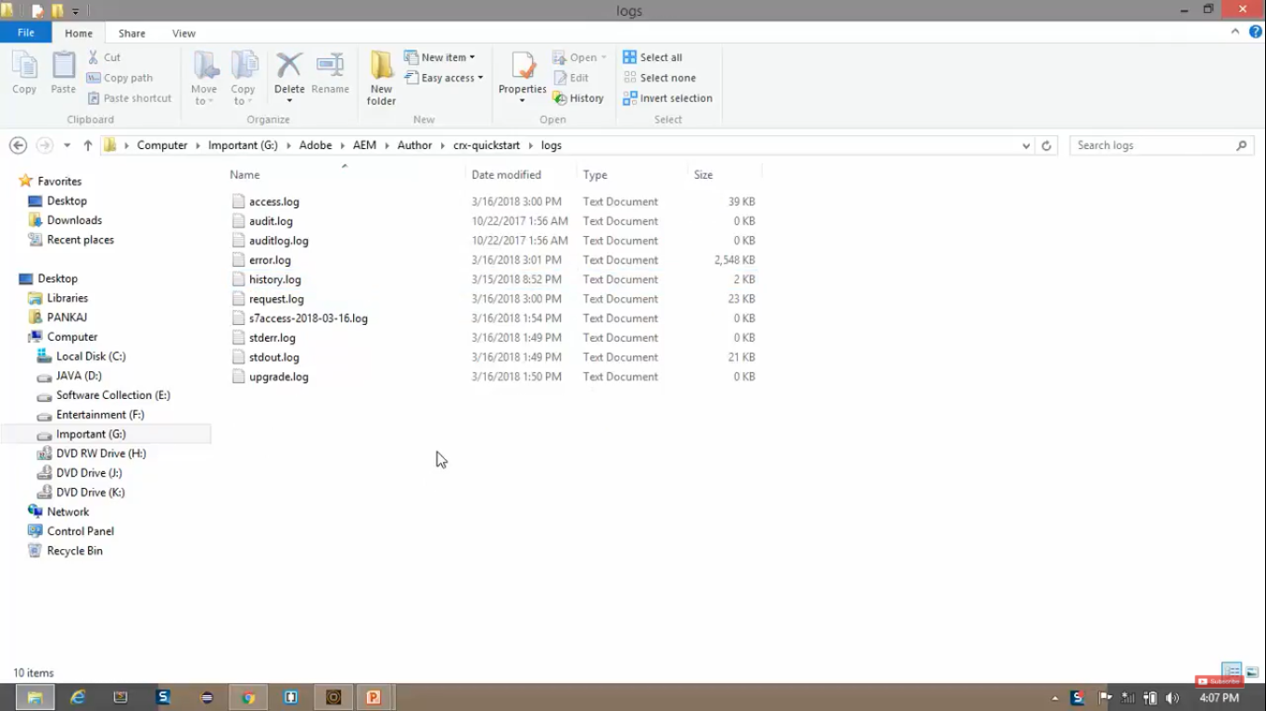

|  |  |
| --- | --- |
| **File Name** | **Used for** |
| 1. access.log | All the request to AEM and repository are registered.  **Who** is accessing and **which resource** is being accessed. |
| 1. audit.log | Provides log of **who** did **what** and **when** |
| 1. error.log | Error messages are registered here |
| 1. history.log | Hold information about the things your editors do.  Editing, deleting, and viewing a page. |
| 1. request.log | All Requests and Responses are registered here.  It is used to monitor and analyse about how much response time a request took to process itself. |
| 1. stderr.log | Error messages generated during AEM startup process. |
| 1. stdout.log | Hold events information during startup  Example, setting sling.properties, sling.home, sling.launchpad, and HTTP server port = 4502, etc. |

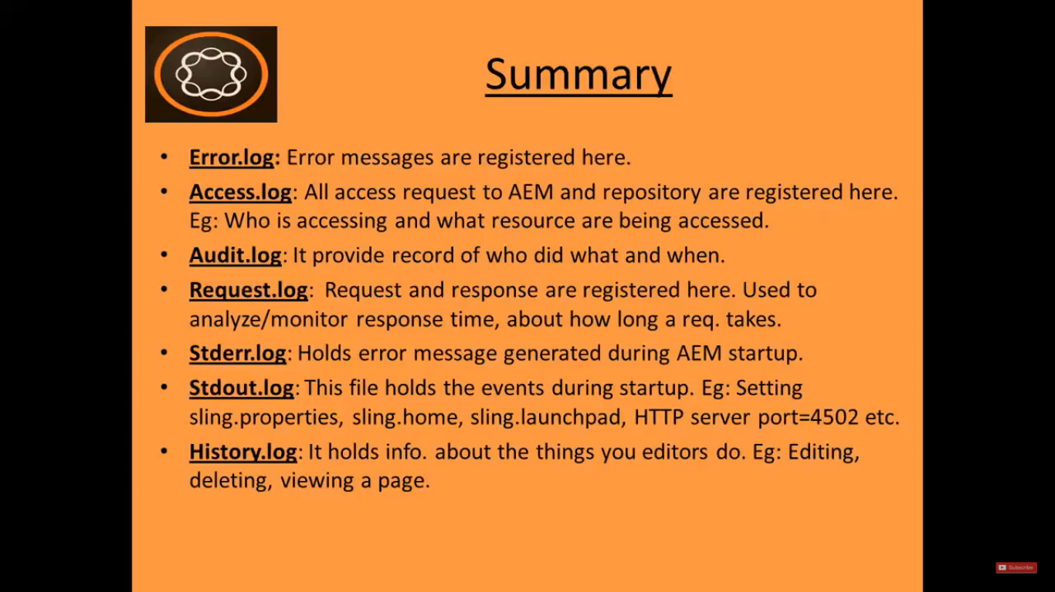

1. In addition to these *default system log files*, you can **create** your **own custom log files** and **customise the messages** in those custom log files.
2. **Custom log files** helps you **better track messages** *produced by your own application* and *separate them from default system log file entries*.
3. Adding **log messages** to **component scripts** will help you to **easily debug various script** included in you application.
4. **AEM** and **CRX/DE** has implemented popular **Log Forge** *framework* which is designed to provide an *easy to use logging solution*.
5. 2-pieces of information are required to append an entry to the log file.

A) **Log Level**

This is *provided by corresponding method call*.

* + - trace()
    - debug()
    - info()
    - warn()
    - error()

B) **Log Message**

Message is provided *as parameter to the method call*.

Below method appends custom message with the log.

**Log.debug**(“This is the custom log message”);

# 36. Create Custom Log file using JavaScript in AEM

1. Go to **System Console**. <http://localhost:4502/system/console>
2. Click on **Sling** menu. Click on **Log Support** sub-menu. (See image below)
3. In the **last row** of the **table**, Click on **Add new Logger**. --> N**ew row** will be **created** in **edit** mode.
4. **Enter** below **values** in respective **columns** of the **table**. --> Click on **Save** button. (See image below)

|  |  |
| --- | --- |
| **Column Name** | **Column Value** |
| Log File | logs\training.log |
| Logger | apps.training |

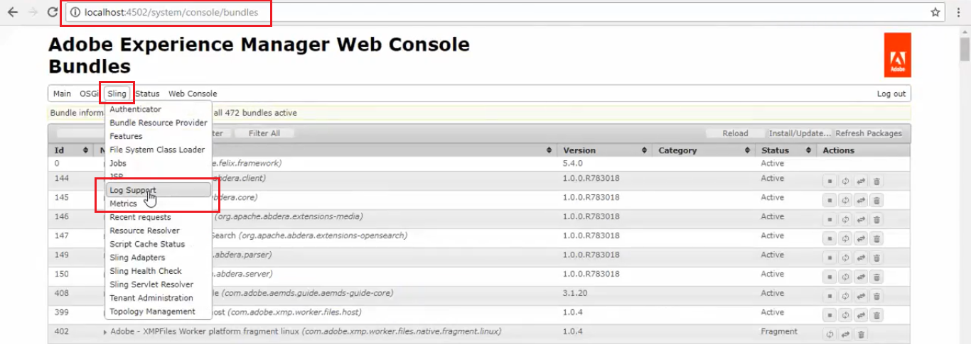

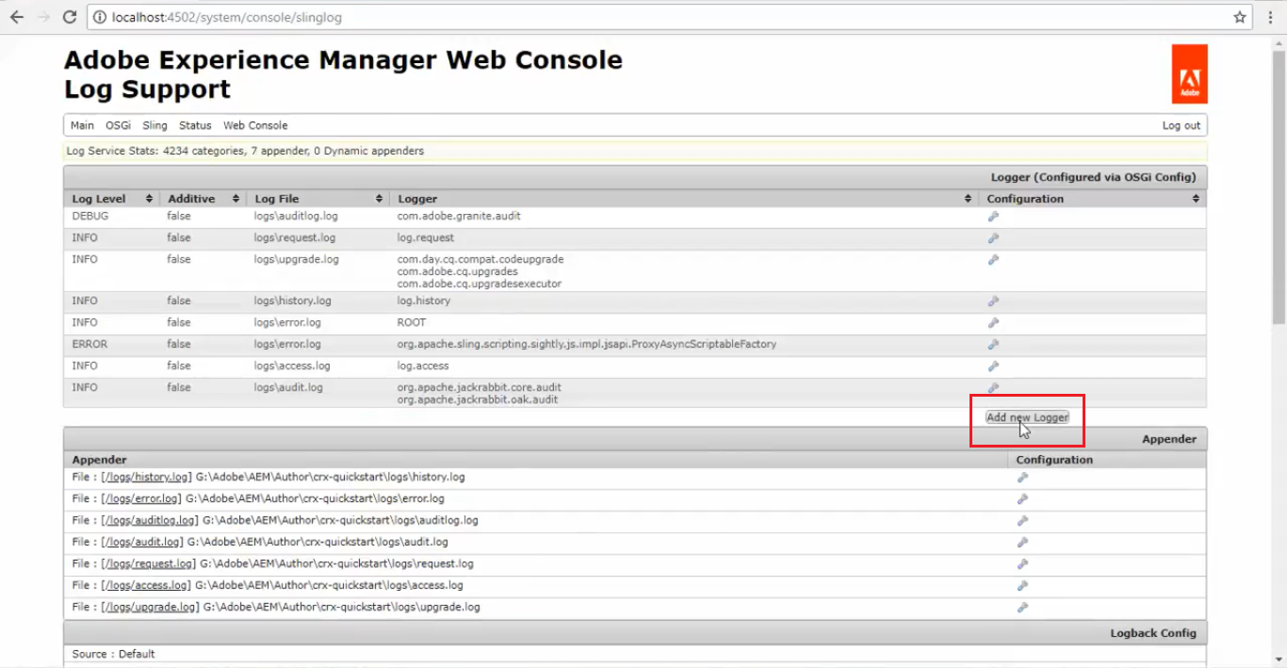

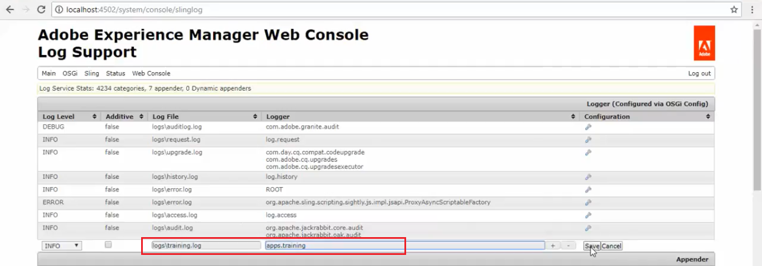

1. **Double click** on **/apps/training/components/structure/site-topnav**/**TopNav.js** node **to edit** content.

Add below code in the file:

**Log.info**(“##### Root page is: ” + root.getTitle());

Go to <http://localhost:4502/content/we-train/en.html>

Open file **training.log** from **AEM instance installed folder** from path **AEM/Author/crx-quickstart/logs**

You can see the **Log Entry** in this file.

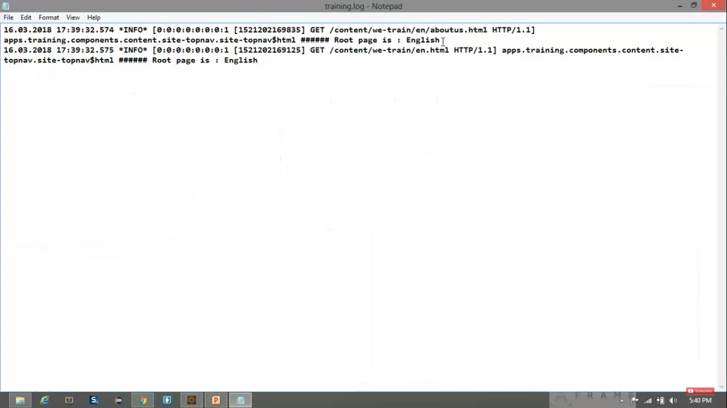

# 37. Add logging to the Java Helper in AEM

1. Import below 2 libraries in file **/apps/training/components/content/site-topnav/TopNav.java**

import org.slf4j.Logger;

import org.slf4j.LoggerFactory;

1. Create a class level **object** of **Logger** class:

Logger logger = LoggerFactory.getLogger(TopNav.class);

1. Add below code inside **activate()** method of the class:

logger.info(“Called in TopNav java helper”);

1. Click on **Save** button.
2. **Replace** 1st line code in file **/apps/training/components/content/site-topnav/site-topnav.html** with

<div data-sly-use.topnav=”TopNav” class”container weContainer—top-navbar”>

1. Go to <http://localhost:4502/content/we-train/en.html>
2. Open file **training.log** from **AEM instance installed folder** from path **AEM/Author/crx-quickstart/logs**

You can see the **Log Entry** in this file.

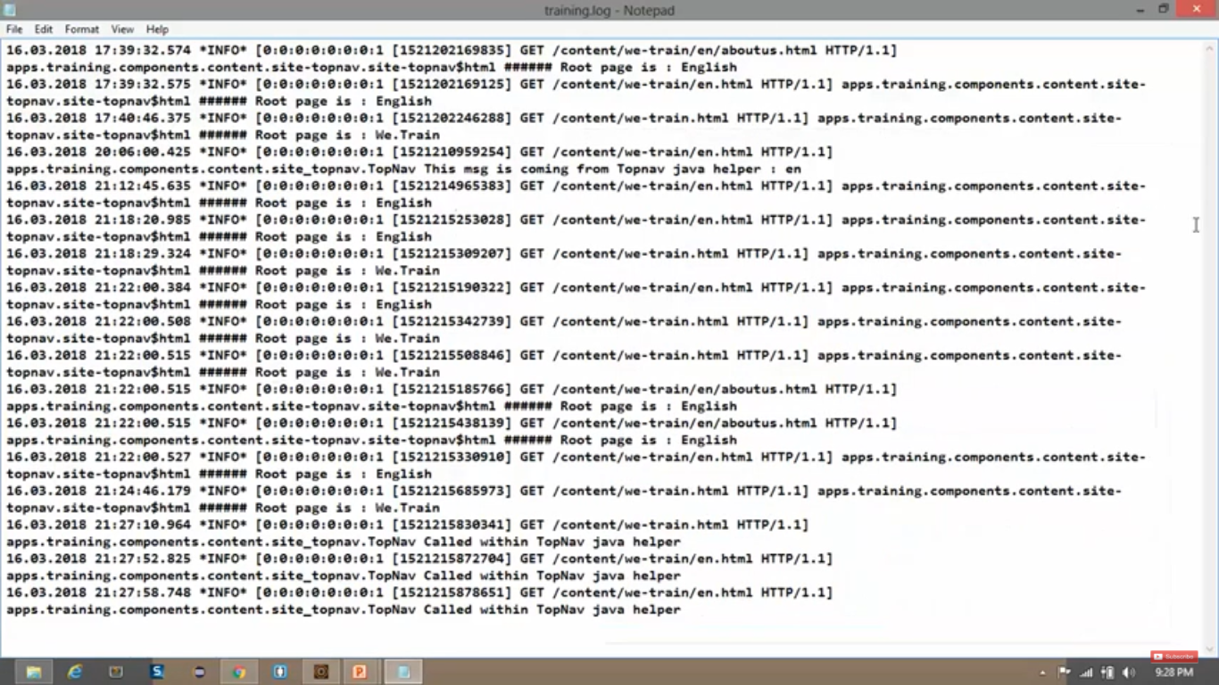

# 38. Touch Optimised dialog box and Classic dialog box in AEM

1. Go to AEM --> Sites --> **Geometrixx demo site** website --> **English** page --> **Edit** button on top
2. We’ll see the **Page** in browser. **Double** click on the section called “World Leader in Applied Geometry”.
3. We will see a **Edit** dialog boxwhere you can *edit the text* which is displayed on the website.

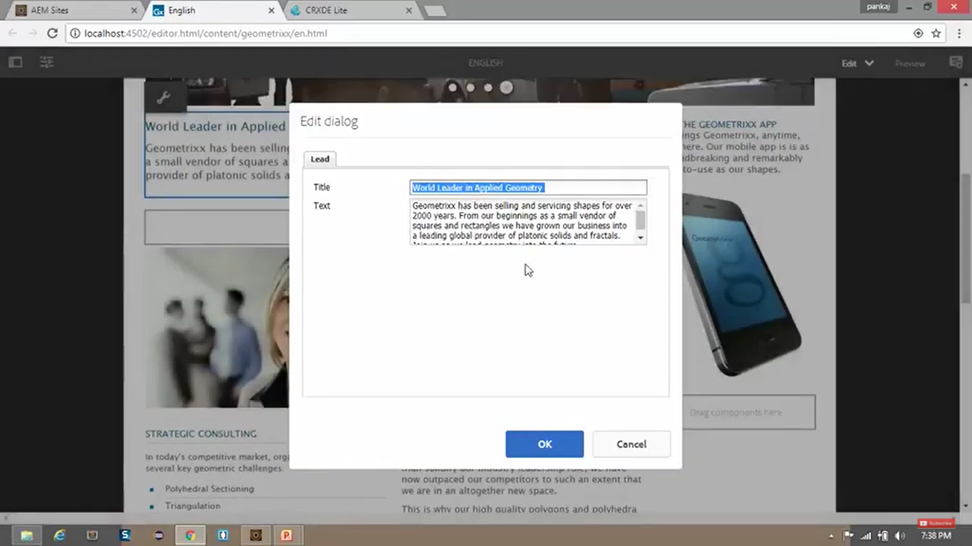

* **Dialog box** is a small temporary window which is used to **take input** from **user** and **edit** **content**.
* Above was a **Classic** dialog box which has **WHITE** background.

1. Now double click on the **image** to see **Touch-optimised** dialog box, which has **BLACK** background.

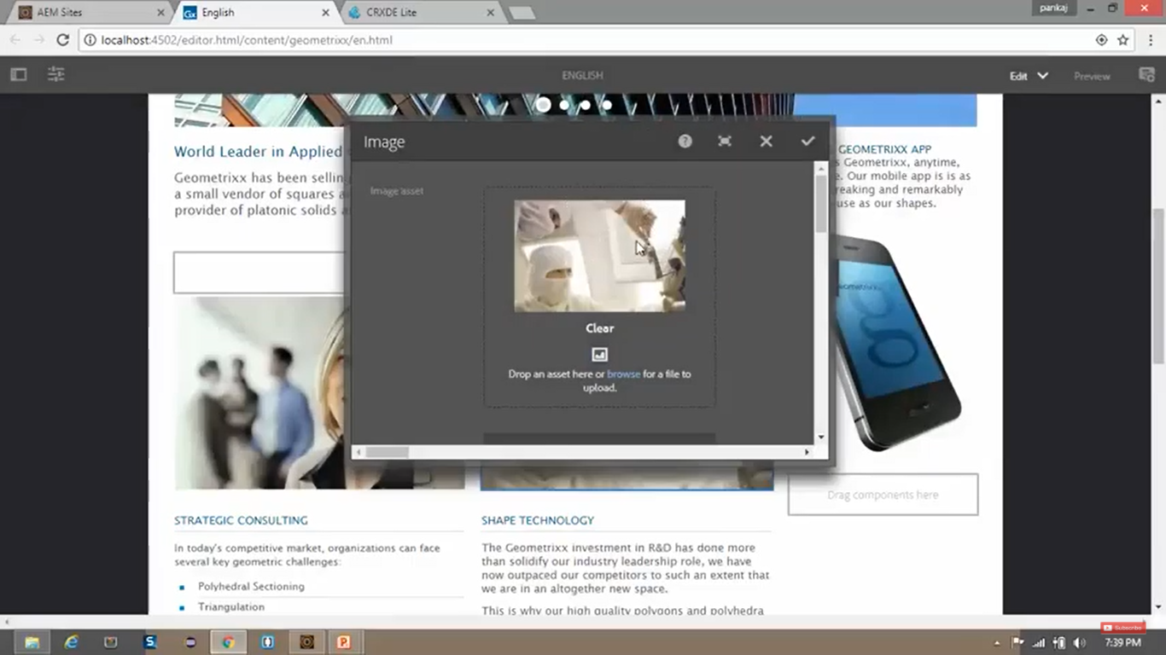

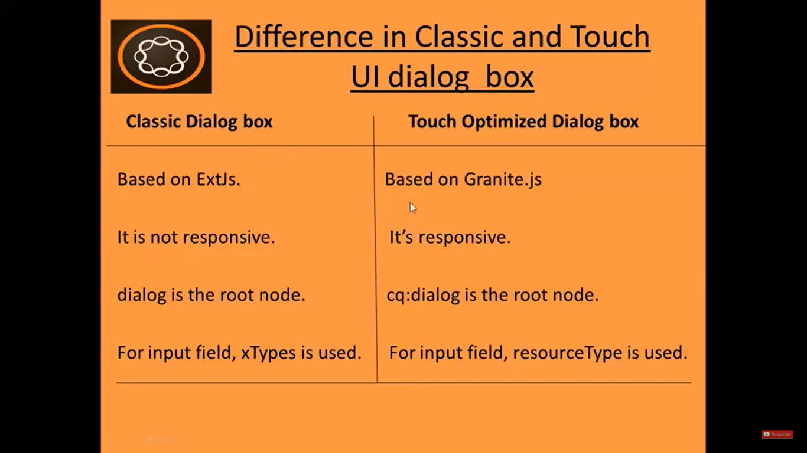

1. Go to CRX DE path **/libs/wcm/foundation/components** (all built-in components available in **AEM**)
2. If you open **title component** in **/libs/wcm/foundation/components**, you can see

|  |  |
| --- | --- |
| **Root Node** | **Dialog box** |
| **cq:dialog** | **Touch Optimized** Dialog Box |
| **dialog** | **Classic** Dialog Box |

1. Go to **Google**, Search for **AEM widget API** --> Click on **CQ5 Widget API** link.
2. On that page, in **Explorer Pane**, Explore nodes **CQ** --> **Ext** --> **form**
3. Here you will see the **list of fields** which are **available** for **Classic** Dialog Box**.**

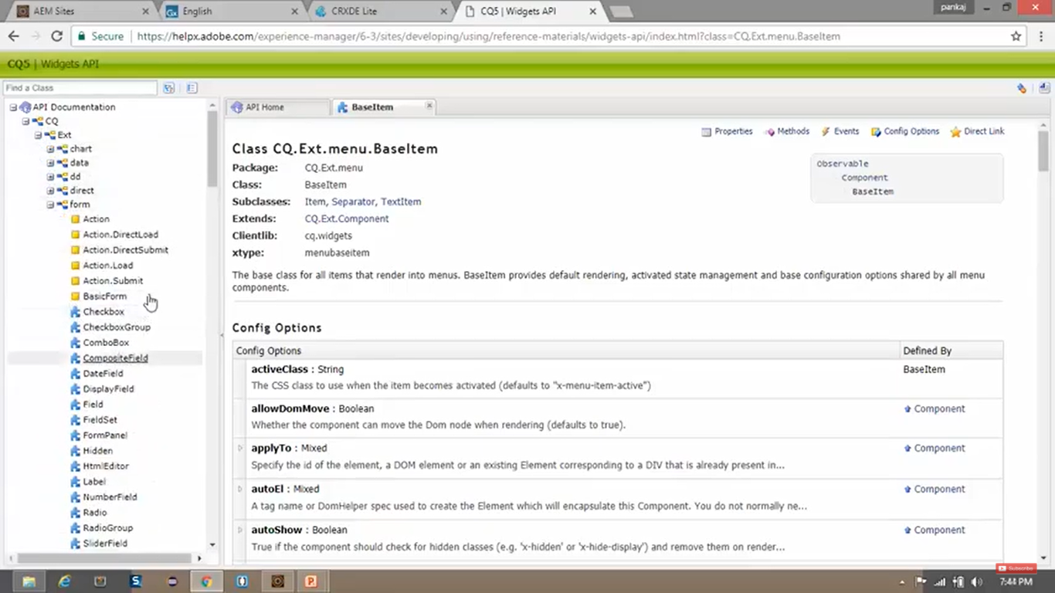

1. Go to **CRX/DE** path **/libs/granite/ui/components/foundation/form**.
2. Here you will see the **list of fields** which are **available** for **Touch Optimised** Dialog Box**.**

# 39. Create Title Component in AEM

1. Go to **CRX/DE**. Right click on **/apps/training/components/content** --> **Create** --> Create **Component**.
2. Add below **values** --> click **Next** button --> Click on **OK** button.

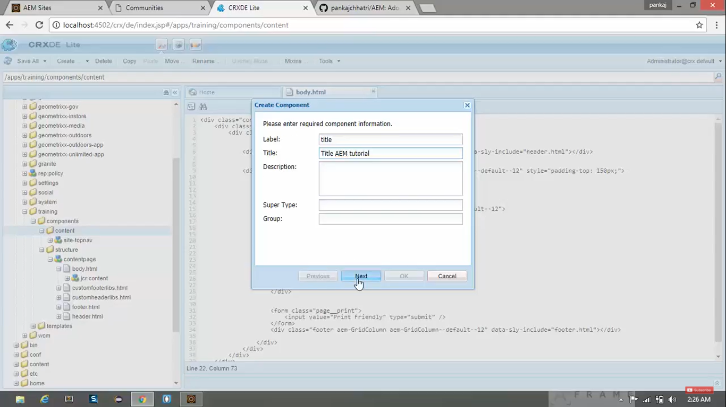

1. **Rename** file from **/apps/training/components/content/title/title.jsp** to **title.html** (Sightly Syntax)
2. Create **new JS file** under **/apps/training/components/content/title**. Name it as **title.js**
3. Click on **Save** button.
4. Go to <https://github.com/pankajchhatri/AEM> --> [Developer course](https://github.com/pankajchhatri/AEM/tree/master/Developer%20course/Chapter%2010%20Authoring%20Structure%20Components/Lab%20Activity%20-%20III/Task%201%20-%20Create%20Title%20Component) --> [Chapter 10 Authoring Structure Components](https://github.com/pankajchhatri/AEM/tree/master/Developer%20course/Chapter%2010%20Authoring%20Structure%20Components/Lab%20Activity%20-%20III/Task%201%20-%20Create%20Title%20Component) --> [Lab Activity – I](https://github.com/pankajchhatri/AEM/tree/master/Developer%20course/Chapter%2010%20Authoring%20Structure%20Components/Lab%20Activity%20-%20I/) --> [Task 1 - Create Title Component](https://github.com/pankajchhatri/AEM/tree/master/Developer%20course/Chapter%2010%20Authoring%20Structure%20Components/Lab%20Activity%20-%20I/Task%203%20-%20Create%20a%20complex%20navigation%20component%20with%20Java%20Helper)
5. **Copy** the contents of **title.js** and **title.html** into our respective files. Click on “Save All” button.

**title.js**

"use strict";

use(function () {

var CONST = {

PROP_TITLE: "jcr:title",

PROP_TAG_TYPE: "type"

}

var title = {};

// The actual title content

title.text = properties.get(CONST.PROP_TITLE)

|| pageProperties.get(CONST.PROP_TITLE)

|| currentPage.name;

return title;

});

**title.html**

<h1 data-sly-use.title="title.js">${title.text}</h1>

1. Copy below code in “body.html” file at line number 21. Click on “Save All” button.

<div class="we-Header" data-sly-resource="${'title' @ resourceType='training/components/content/title'}"></div>

1. Go to URL [http://localhost: 4502/content/we-train/en.html](http://localhost:%204502/content/we-train/en.html)
2. You can see title component shown on your page.

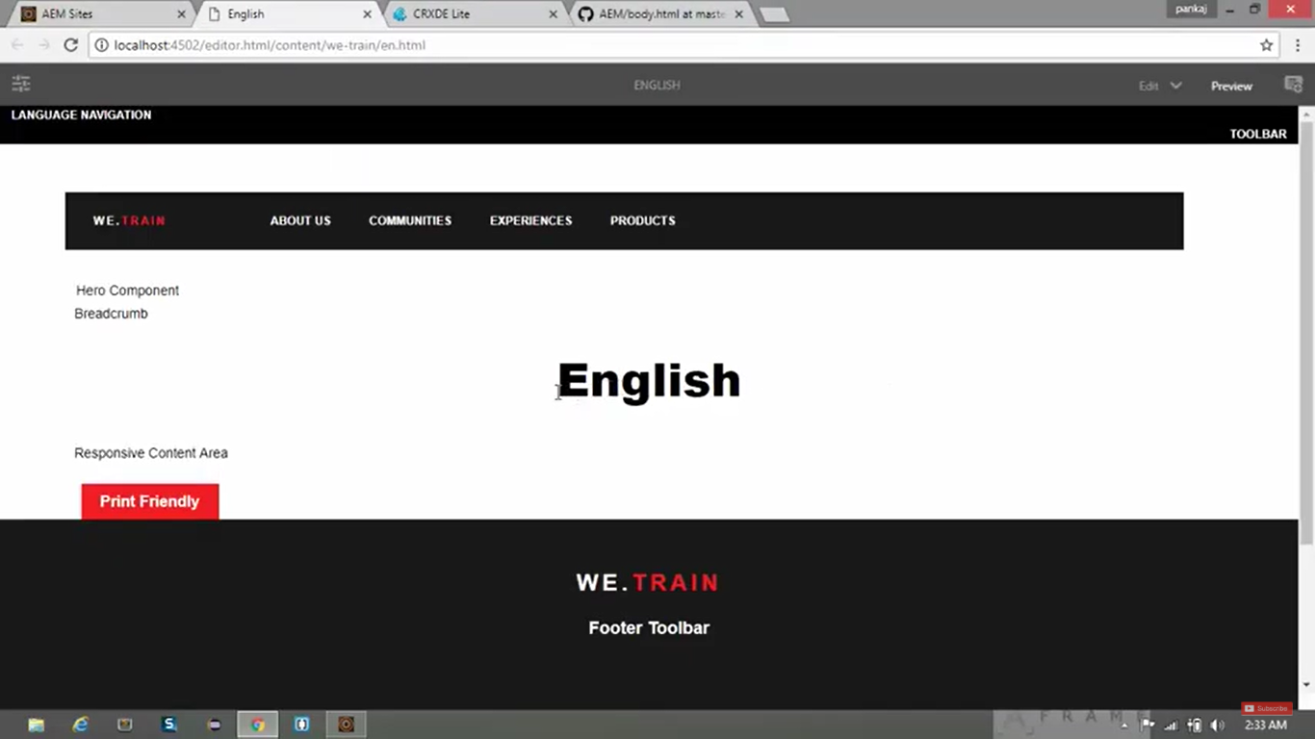

1. Go to URL [http://localhost: 4502/content/we-train/en/aboutus.html](http://localhost:%204502/content/we-train/en/aboutus.html)
2. You can see title component shown on your page.

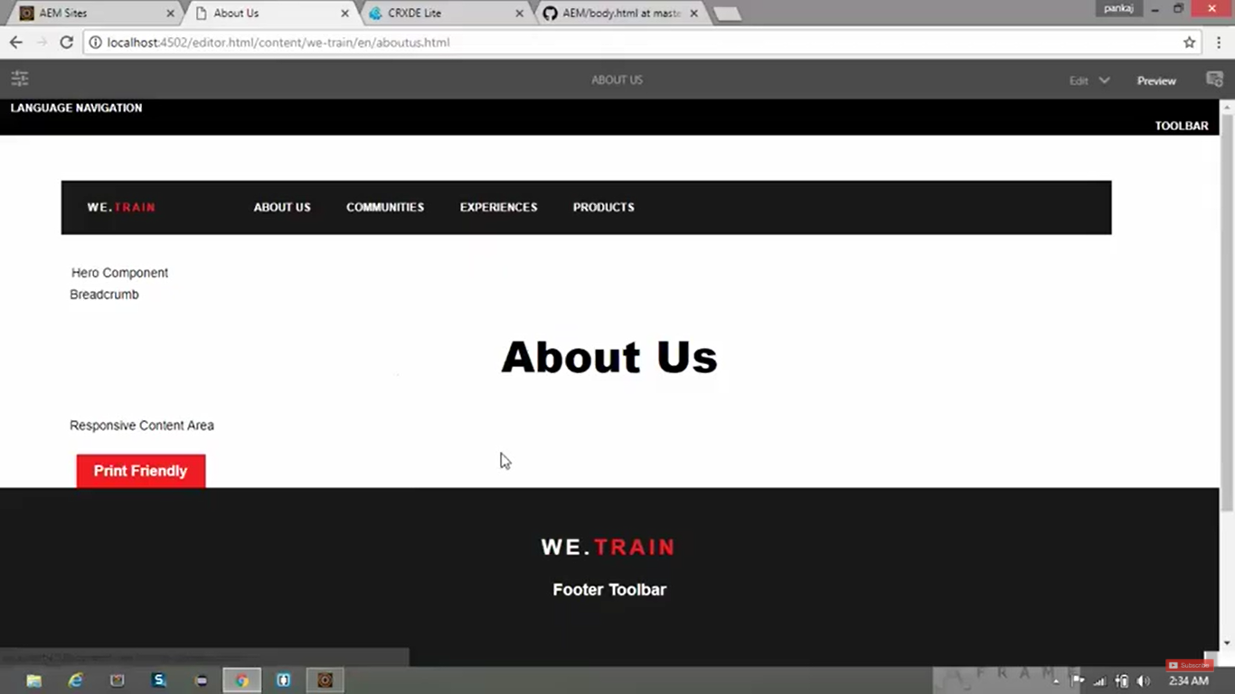

# 40. Create a Touch-Optimised dialog box for the Title Component in AEM

1. In last section, we have created **Title Component** which **displays** its **page title** by default, **but** there is **no way to customise** this **title** of the page.
2. In this section, we will create the **editable** dialog box, where **Author** can **Edit** and **enter** custom **title**.
3. We will create **Touch Optimised** dialog box under path **/apps/training/components/content/title**.
4. Copy **/libs/wcm/foundation/components/title/cq:dialog** node --> Paste at above path.
5. Select the same copied **cq:dialog** node and open properties pane.
6. Set below property.

|  |  |
| --- | --- |
| **Property** | **Value** |
| Jcr:title | We.Train site |

1. Go to **/apps/training/components/content/title/cq:dialog/content/items/column/items**.
2. Delete **type** node under above mentioned path.

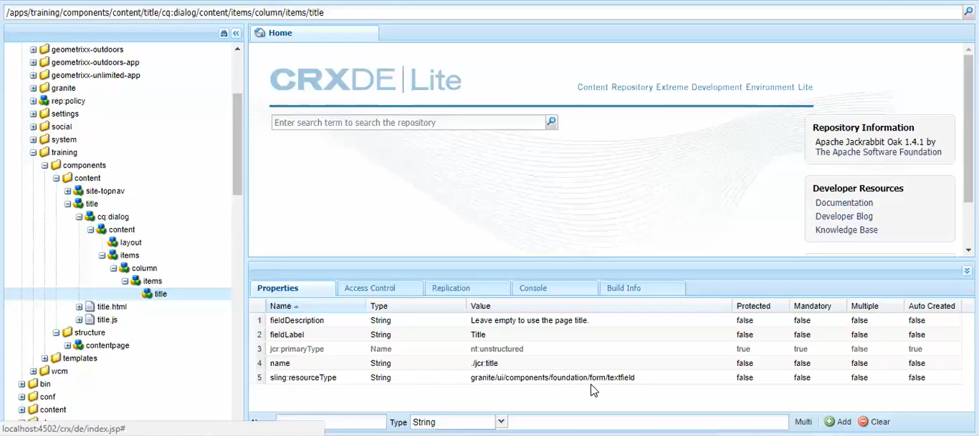

1. If you open **URL** [http://localhost: 4502/editor.html/content/we-train/en.html](http://localhost:%204502/editor.html/content/we-train/en.html), even if you **double click** on the **title** (English text), you will still **not** be able to **edit** the title of the page.
2. **To make it editable**, we need create a **node** of type **cq:EditConfig** using below steps.
3. **Right click** on **/apps/training/components/content/title** --> **Create** --> Create **Node** -->
4. Give below values

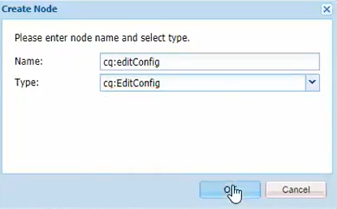

**Refresh** the page again to see the result. **Double click** on title **English** text component.

It will open a **Touch Optimised** dialog box with BLACK background.

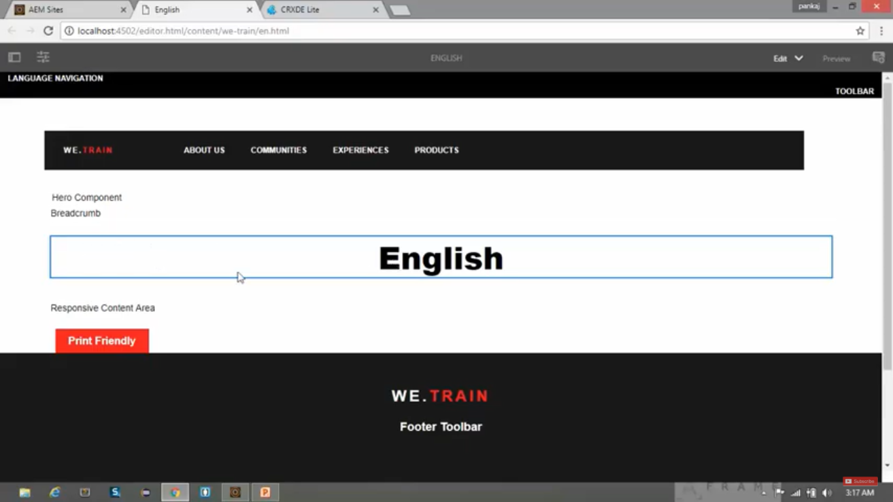

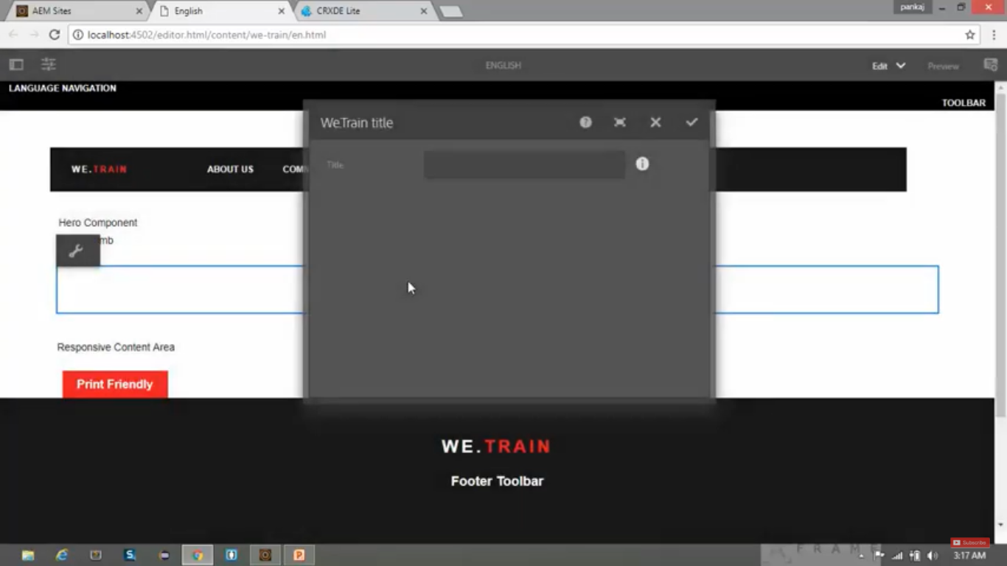

See the properties below:

|  |  |
| --- | --- |
| **Property** | **Value** |
| fieldLabel | It will be shown as textbox **title** on dialog box. |
| fieldDescription | It will shown as **tooltip** next to textbox on dialog box. |

If you change the **title** to **En** from dialog box. You will see the **new value** of the **title** is *saved* in **CRX/DE**.

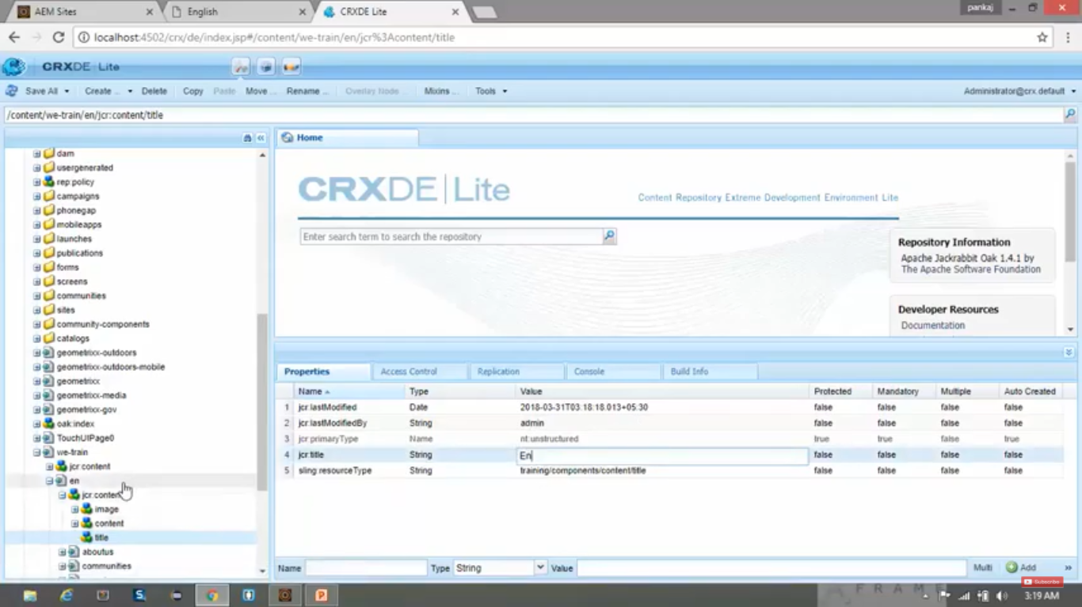

**Conclusion:**

To create **non-editable dialog box**, you need to create a **node** of type **cq:dialog**.

To create **editable dialog box**, you need to create 2 **nodes** of type **cq:dialog** and type **cq: editConfig**.